|  |
| --- |
|  |
| Arctic LNG 2 Project  **Invasive Species Addendum** |
| **Prepared by:**  **Ramboll CIS**  **Date:**  January, 2022 |

|  |  |
| --- | --- |
| **Agreement:** | 228-ALNG2-2020 of 31.03.2020 |
| **Assignment:** | Environmental, socio-economic and human health impact assessment (ESHIA) for the Arctic LNG 2 Project |
| **Issue:** | 1 |
| **Authors:** | Dr. Sergey Dudov, Dr. Vadim Khaitov, Dr. Nikolay Usov, Dr. Mikhail Kozhin |
| **Project Manager/Director:** | Ivan Senchenya |
|  |  |
| **Date:** | 31.01.2022 |
|  |  |

*This Report is prepared by Ramboll CIS in accordance with the professional standards and quality requirements of the assignment, taking into account scope of the services and the terms agreed with the Client. This Report can be used solely by the Client or his advisers, thus the company does not assume any liability to third parties who may rely on the Report or any part thereof, except upon prior agreement with Ramboll CIS. Any use of the Report materials by such third party shall be at its own risk.*

*Ramboll CIS does not assume any liability to the Client or other parties in relation to any matters beyond the scope of its services.*

|  |  |  |  |  |
| --- | --- | --- | --- | --- |
| Version Control Record | | | | |
| **Version** | **Content and status** | **Date** | **Reviewer initials** | **Author(s) initials** |
| A | Draft for internal review | IS | IS, SCh | SD, VKh, NU, MK |
| 1 | First draft issued to the Client | 31.01.2022 | IS | SD, VKh, NU, MK |
| 2 | Revision with Client’s comments incorporated | 18.03.2022 | NC, JT | SD, VKh, NU, MK |
| 4 | Second draft issued with comments addressed |  |  |  |

**CONTENTS**

[Acronyms 4](#_Toc1897932859)

[List of figures 5](#_Toc58347796)

[List of tables 6](#_Toc1218201040)

[1. Introduction 7](#_Toc593978568)

[1.1 Report Objectives 7](#_Toc2090203944)

[1.2 Key terms 7](#_Toc204585471)

[1.3 Arctic LNG 2 project and its predicted environmental impacts 8](#_Toc247150008)

[1.4 Potential ways of introduction of non-indigenous species 9](#_Toc613764993)

[1.4.1 General scheme 9](#_Toc1374828404)

[1.4.2 Marine environment 10](#_Toc785852995)

[1.4.3 Terrestrial ecosystems 13](#_Toc1534427676)

[1.5 Limitations 14](#_Toc571212233)

[2. Assessment Methodology 15](#_Toc129697243)

[2.1 Marine biota 15](#_Toc1655526603)

[2.1.1 Analysis of geographic distribution of hydrobionts 15](#_Toc1239205512)

[2.1.2 Assessment of environmental parameters 16](#_Toc1214502860)

[2.1.3 Statistical analysis 16](#_Toc2147084102)

[2.2 Terrestrial biota 16](#_Toc1988495717)

[2.2.1 Data resources on vascular plants 16](#_Toc694774708)

[2.2.2 Species distribution modelling 18](#_Toc1745119486)

[3. Assessment Results 20](#_Toc439470791)

[3.1 Marine environment 20](#_Toc692608907)

[3.1.1 Hydrological conditions in the Ob Estuary 20](#_Toc183791209)

[3.1.2 Biogeographical analysis of potential planktonik and benthos NIS in marine realms 25](#_Toc540851198)

[3.1.3 Description of most expected invasive marine invertebrate species 34](#_Toc1389138992)

[3.1.4 Alien Fish Species 45](#_Toc157013744)

[3.2 Terrestrial Realms 46](#_Toc1114765746)

[3.2.1 Alien Plants in the Yamal-Gydan sector of the Arctic 46](#_Toc897321047)

[3.2.2 The Most Expected Invasive Plants 49](#_Toc2012251088)

[3.2.3 Invasive Plants and Climate Change 53](#_Toc2133909332)

[3.2.4 Conclusions 54](#_Toc420845036)

[4. recommendations 56](#_Toc1762700299)

[5. Conclusion 57](#_Toc44773481)

# Acronyms

|  |  |
| --- | --- |
| AOI | Area of [Project] Influence |
| CAFF | The Conservation of Arctic Flora and Fauna |
| CBD | Convention of Biological Diversity |
| CMIP5 | Coupled Model Intercomparison Project phase 5 |
| DNA | Deoxyribonucleic acid |
| EBSAs | Ecologically or Biologically Significant Marine Areas |
| eDNA | Environmental DNA [approach] |
| ESAP | Environmental and Social Action Plan |
| ESHIA | Environmental, Social and Health Impact Assessment |
| GBS | Gravity Based Structure |
| GDS | Geographical Dataset |
| GIS | Geographic information system |
| IEPI | Institute of Environmental Survey, Planning and Assessment |
| IFC | International Finance Corporation |
| JSC | Joint Stock Company |
| GBIF | Global Biodiversity Information Facility [data portal] |
| LA | License Area |
| LNG | Liquefied natural gas |
| MSU | Lomonosov Moscow State University |
| NIS | Non-indigenous species |
| NSR | Northern Sea Route |
| OGCF | Oil, gas, and condensate field |
| PNIS | Potentially Non-indigenous species |
| PCA | Principal Component Analysis |
| PS | IFC Performance Standards |
| RAS | The Russian Academy of Sciences |
| RF | Russian Federation |
| SSP | Shared Socioeconomic Pathways [scenario] |
| SGC | Stabilised gas condensate |
| SST | Sea surface temperature |
| YNAO | Yamal-Nenets Autonomous Okrug |
| VIF | Variance Inflation Factor |

# List of figures

[Figure 1.1: Project Area of Influence. Diagonal hatch indicates EBSA. Dashed line – Northern Sea Route 9](C:\\Users\\sergd\\Desktop\\WORK\\invasive_species\\Arctic_LNG2_Invasive_Addendum_project_v02.docx" \l "_Toc99727718)

[Figure 1.2: Routes of vessels moving to and from terminals (existing and under construction) Ob Estuary in July 2021. Source: https://arctic-lio.com/category/maps/ 12](#_Toc99727719)

[Figure 1.3: Routes of vessels moving to and from terminals (existing and under construction) Ob Estuary in August 2021. Source: https://arctic-lio.com/category/maps/ 13](#_Toc99727720)

[Figure 1.4: Routes of vessels moving to and from terminals (existing and under construction) Ob Estuary in September 2021. Source: https://arctic-lio.com/category/maps/ 13](#_Toc99727721)

[Figure 1.5:](#_Toc99727722) *[Limnocalanus grimaldii](#_Toc99727722)* [in samples of ballast water (Integrated investigations… 2020) 14](#_Toc99727722)

[Figure 1.6: Cultivated meadow on restoration road embankments in the Gydan Peninsula. IEPI, 2020 15](#_Toc99727723)

[Figure 2.1: Extent for species distribution modelling. Blue dots on the Salmanovskiy (Utrenniy) LA used for the analysys of habitat suitability change in future. Prepared by Consultant 21](#_Toc99727724)

[Figure 3.1: Position of ports in the Ob estuary. Blue area marks a set of points nearest to ports selected for analysis of variation in hydrological parameters calculated by INMOM model. Prepared by Consultant 24](#_Toc99727725)

[Figure 3.2: Salinity in the Ob estuary in four seasons. Prepared by Consultant 25](#_Toc99727726)

[Figure 3.3: Surface temperature in the Ob estuary in four seasons. Prepared by Consultant 26](#_Toc99727727)

[Figure 3.4: T-S diagram reflecting limits of salinity and temperature variation in the area of ports in different seasons. Prepared by Consultant 27](#_Toc99727728)

[Figure 3.5: Frequency distribution of PC1 scores for native and PNIS between benthic and planktonic species. Prepared by Consultant 29](#_Toc99727729)

[Figure 3.6: Occurence of benthic and planktonic native species and PNIS in different hydrological conditions. The boundary of ecological license of Ob estuary in cold and warm seasons are represented by blue rectangles. The red rectangles reflect expanded ecological license. Green lines reflects areas with maximal point density. Prepared by Consultant 30](#_Toc99727730)

[Figure 3.7: Worldwide distribution of](#_Toc99727731) *[Prorocentrum cordatum](#_Toc99727731)* [accordingly to GBIF. Prepared by Consultant 37](#_Toc99727731)

[Figure 3.8: Worldwide distribution of](#_Toc99727732) *[Acanthocyclops robustus](#_Toc99727732)* [accordingly to GBIF. Prepared by Consultant 38](#_Toc99727732)

[Figure 3.9: Worldwide distribution of](#_Toc99727733) *[Acartia bifilosa](#_Toc99727733)* [accordingly to GBIF. Prepared by Consultant 39](#_Toc99727733)

[Figure 3.10: Worldwide distribution of](#_Toc99727734) *[Amphibalanus improvisus](#_Toc99727734)* [accordingly to GBIF. Prepared by Consultant 40](#_Toc99727734)

[Figure 3.11: Worldwide distribution of](#_Toc99727735) *[Gammarus tigrinus](#_Toc99727735)* [accordingly to GBIF. Prepared by Consultant 41](#_Toc99727735)

[Figure 3.12: Worldwide distribution of](#_Toc99727736) *[Rhithropanopeus harrisii](#_Toc99727736)* [accordingly to GBIF. Prepared by Consultant 42](#_Toc99727736)

[Figure 3.13: Worldwide distribution of](#_Toc99727737) *[Eriocheir sinensis](#_Toc99727737)* [accordingly to GBIF. Prepared by Consultant 43](#_Toc99727737)

[Figure 3.14: Worldwide distribution of](#_Toc99727738) *[Dreissena polymorpha](#_Toc99727738)* [accordingly to GBIF. Prepared by Consultant 44](#_Toc99727738)

[Figure 3.15: Worldwide distribution of Mya arenaria accordingly to GBIF. Prepared by Consultant 45](#_Toc99727739)

[Figure 3.16: Worldwide distribution of Potamopyrgus antipodarum accordingly to GBIF. Prepared by Consultant 46](#_Toc99727740)

[Figure 3.17: Worldwide distribution of Marenzelleria accordingly to GBIF. Prepared by Consultant 47](#_Toc99727741)

[Figure 3.18: Bream (Abramis brama) in the Venuime-Yakha river in 2018 (FRECOM, 2018) 48](#_Toc99727742)

[Figure 3.19: Pink salmon (Oncorhynchus gorbuscha) in the Khaltsyney-Yakha mouth in September 2021 (IEPI, 2021) 48](#_Toc99727743)

[Figure 3.20: Numbers of non-native species per periods 1990-2021 in the Yamal-Gydan sector of the Arctic based on literature data and herbarium specimens. Prepared by Consultant 51](#_Toc99727744)

[Figure 3.21: Percentage of different introduction pathways of non-native species in the Yamal-Gydan sector of the Arctic. Prepared by Consultant 51](#_Toc99727745)

[Figure 3.22: General view (photo by M. Kozhin) and habitat suitability model of](#_Toc99727746) *[Anthriscus sylvestris](#_Toc99727746)* [(L.) Hoffm. subsp.](#_Toc99727746) *[sylvestris](#_Toc99727746)* [(prepared by Consultant) 52](#_Toc99727746)

[Figure 3.23: General view (photo by M. Kozhin) and habitat suitability model of](#_Toc99727747) *[Bromus inermis](#_Toc99727747)* [Leyss. (prepared by Consultant) 53](#_Toc99727747)

[Figure 3.24: General view (photo by L. Palamarchuk by plantarium.ru) and habitat suitability model of](#_Toc99727748) *[Elymus repens](#_Toc99727748)* [(L.) Gould. (prepared by Consultant) 54](#_Toc99727748)

[Figure 3.25: General view (photo by S. Dudov) and habitat suitability model of](#_Toc99727749) *[Stellaria media](#_Toc99727749)* [(L.) Vill. (prepared by Consultant) 55](#_Toc99727749)

[Figure 3.26: General view (photo by M. Kozhin) and habitat suitability model of](#_Toc99727750) *[Trifolium repens](#_Toc99727750)* [L. (prepared by Consultant) 56](#_Toc99727750)

[Figure 3.27: General view (photo by M. Kozhin) and habitat suitability model of](#_Toc99727751) *[Urtica dioica](#_Toc99727751)* [L. subsp.](#_Toc99727751) *[dioica](#_Toc99727751)*[. (prepared by Consultant) 57](#_Toc99727751)

[Figure 3.28: Change of modelled habitat suitability of six plant species on Salmanovskiy (Utrennij) LA under three scenario. Horizontal black lines - median; box - upper and lower quartiles, black points - outliers. Dashed and dotted lines indicate threshold values indicating that environment is suitable for this species (Liu et al., 2013): green line:](#_Toc99727752) *[maximum training sensitivity and specificity threshold,](#_Toc99727752)* [red line:](#_Toc99727752) *[X10.percentile.training.presence](#_Toc99727752)* [(prepared by Consultant) 58](#_Toc99727752)

# List of tables

[Table 1.1: The pathways of introduction of invasive species (CBD. 2014, adopted) 9](#_Toc99726817)

[Table 3.1: Number of native and potentialy Non-indigenous speciesinvolved in the biogeografical analysis for benthic and planktonic animals 27](#_Toc99726818)

[Table 3.1: Native species and PNIS for the Ob estuary ecosystem involved in analysis. Biogeographical characteristics: $Qlow$- 2.5% quantile of latitude, - median of latitude, - 97.5% quantile of latitude. - number of references in GBIF with environmental parameters inside the ecological license of the Ob estuary. $Ntotal$- total number of references with salinity and temperature assessed. $Pinv$-assessment of invasion probability 30](#_Toc99726819)

[Table 3.3: Check-list of non-native vascular plants in the Yamal-Gydan sector of the Arctic (Prepared by Consultant). 48](#_Toc99726820)

# Introduction

## Report Objectives

This report is focused on the preparation of the precautionary list of the invasive alien species that have potential to be introduced or spread in terrestrial and marine environments of the Arctic LNG 2 Area of Influence by the activity connected to project development. The report is prepared to address PS6-14 of the ESAP: “*Confirm species that have potential to be introduced or spread in terrestrial and marine environments*”.

Invasive alien species are recognized to be a major global threat to biodiversity and ecosystem services. Paragraph 22 of PS 6 IFC states that “*The client will not intentionally introduce any new alien species (not currently established in the country or region of the project) unless this is carried out in accordance with the existing regulatory framework for such introduction. Notwithstanding the above, the client will not deliberately introduce any alien species with a high risk of invasive behavior regardless of whether such introductions are permitted under the existing regulatory framework. All introductions of alien species will be subject to a risk assessment (as part of the client’s environmental and social risks and impacts identification process) to determine the potential for invasive behavior. The client will implement measures to avoid the potential for accidental or unintended introductions including the transportation of substrates and vectors (such as soil, ballast, and plant materials) that may harbor alien species*”.

According to IFC PS 6 paragraph 23: “Where alien species are already established in the country or region of the proposed project, the client will exercise diligence in not spreading them into areas in which they have not already been established. As practicable, the client should take measures to eradicate such species from the natural habitats over which they have management control”.

The purpose of the document is to reveal the most likely invasive alien species, the introduction of which in the ecosystems of the project's Area of Influence is possible during the Project's activities.

This report covers the problem of invasive species in the Ob Estuary and on the Gydan Peninsula in the Project’s Area of Influence. Cumulative risk of invasive alien species along the NSR is considered in a separate document “Strategic assessment of shipping activities along the Northern Sea Route. Arctic LNG 2 Project. Ramboll CIS, 2021”.

## Key terms

**Ecosystems** is a dynamic complex of plant, animal, and microorganism communities and the nonliving environment interacting as a functional unit. Humans are an integral part of ecosystems. Ecosystems vary enormously in size; a temporary pond in a tree hollow and an ocean basin can both be ecosystems

**Plankton** — pelagic animals that are unable to propel themselves against a current.

**Benthos** — organisms that live on, in, or near the bottom of a sea, river or lake.

**Phytoplankton** – small, mostly unicellular, algae forming a vegetative part of plankton

**Zooplankton** – animal part of plankton.

**Ballast water** is taken into the hull of ship to maintain its stability when a ship is not loaded or is only partially loaded.

**Fouling, or biofouling,** means the accumulation of aquatic organisms such as micro-organisms, plants, and animals on surfaces of structures immersed in or exposed to the aquatic environment.

**Indigenous**, of **Native**, species is an organism, normally observed for a long time in this area and where it is embedded in the local ecosystem and its vital activity is constrained by the interaction with other organisms, and these interactions are the product of coevolution.

**Native area** is an area, where organism is normally observed for a long time, and where it is embedded in the local ecosystem.

**Introduction** — means that the organisms (or its propagule) has overcome, through human agency, a major geographical barrier.

**Ecological license, or ecological permit** - the set of conditions in an ecosystem owing to which a population already existing or emerging there has or obtains (1) a specific position in space and time, (2) a specific position in the gradient of environmental factors, and (3) a specific role in the flows of matter, energy, and information (Ozerskii, 2011).[[1]](#footnote-0)

**Non-indigenous species** (NIS) — species introduced outside their natural past or present range, which might survive and subsequently reproduce in new area.

**Potentially Non-indigenous species** (PNIS) — species which were referred as *NIS* in previous investigations in any area of world.

**Invasive Species** or Invasive Alien Species are non-native species that may spread rapidly by outcompeting other native plants and animals when they are introduced into a new habitat that lacks controlling factors as determined by natural evolution.

**Native plants —** taxa that have originated in a given area without human involvement or that have arrived there without intentional or unintentional intervention of humans from an area in which they are native/

**Casual alien plants** — alien plants that may flourish and even reproduce occasionally outside cultivation in an area, but that eventually die out because they do not form self-replacing populations, and rely on repeated introductions for their persistence.

**Invasive plants** — are a subset of naturalized plants that produce reproductive offspring, often in very large numbers, at considerable distances from the parent plants, and thus have the potential to spread over a large area.

**Naturalized plants (established plants)** — alien plants that sustain self-replacing populations for at least 10 years without direct intervention by people (or in spite of human intervention) by recruitment from seed or ramets (tillers, tubers, bulbs, fragments, etc.) capable of independent growth.

**Non-native plants** — plant taxa in a given area whose presence there is due to intentional or accidental introduction as a result of human activity

**Transformer** — a subset of invasive plants which change the character, condition, form or nature of ecosystems over a substantial area relative to the extent of that ecosystem.

## Arctic LNG 2 project and its predicted environmental impacts

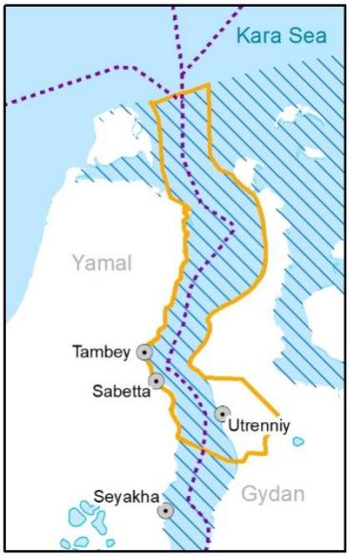The Arctic LNG 2 is a project in the sphere of hydrocarbons extraction, production and offloading of liquefied natural gas and stabilized gas condensate. The Project comprises three process trains for production 6.6 MTPA of liquefied natural gas each, and up to 1.6 MTPA of stabilised gas condensate. The combined capacity of the three LNG trains is 19.8 MTPA. The resource base for the Project is the Salmanovskoye (Utrenneye) oil, gas, and condensate field (OGCF) at the border of the Gydan and Yamal petroleum regions in the West-Siberian oil-and-gas bearing province.

The Project includes the following components:

1. Salmanovskoye (Utrenneye) OGCF Facilities Setup (well pads, power supply facilities, gas treatment facilities, water intake and treatment facilities, wastewater treatment and disposal facilities, SMCIW disposal site, helicopter pads, materials and equipment facilities, temporary accommodation camps, Emergency Rescue Centre, infrastructure, temporary facilities for the construction phase;

Figure 1.1: Project Area of Influence. Diagonal hatch indicates EBSA. Dashed line – Northern Sea Route

2. SD, VKh, NU, MK onstruction of the GBS Plant for production, storage and offloading of liquefied natural gas and stabilised gas condensate (GBS with LNG & SGC storage facilities, topside including process modules, loading arms and power supply facilities, onshore facilities (flare system, Operations Control Complex, pipe racks, boiler plant, utilities, drainage channel);

3. Construction of the Utrenniy liquefied natural gas and stabilised gas condensate terminal, including- Temporary berth structures;

- Early development facilities (approach channel, port water area, ALP-1 with a quayside, general-purpose berth, utilities, storage facilities);

- Operating phase facilities (port fleet berth, ice barriers, navigation safety systems).

The main impact on marine ecosystems is expected to be due to propagation of polluting substances and physical impacts (warming effect, turbulence, suspension of sediments, underwater noise, transformation of the thermohaline structure, etc.) along the prevailing directions of flows - i.e. river flows, sea-water penetration, tidal and wind-induced flows. Sea transport will be used during construction and operation of the Project facilities, and the resulting increase of load on the navigation routes and port infrastructure can be considered as a source of direct, indirect and cumulative impacts. The development of hydrocarbons in Yamal and Gydan will lead to an increase in ship traffic The growth of ship traffic as cumulative impact which will continue in the Ob Estuary even without the participation of the Company will lead to noise pollution, the risks of ship strikes both in ice-covered and ice-free seasons and oil spills. As a result of the Project implementation, an increase in vessel traffic on the shipping routes of the Northern Sea Route is expected, which is also a cumulative risk for marine biota including the introduction of NIS.

The Area of project Influence (AoI) is presented on Figure 1.1. The AoI has been agreed as the basis for ESHIA and planning with lenders and is limited to some extent by management control of the Project. The rationale for the AoI is presented in the “Project Area of Influence. Arctic LNG2 Project. Addendum to the ESHIA”.

The impact on terrestrial ecosystems is expected in relation to long-term and short-term land take/ habitat loss, compaction of soil, alteration of soil hydrology, noise, disturbance, light pollution, deposition of pollutants emitted to the air, activation of exogenous geological processes. Displaced husbandry activity will potentially lead to overgrazing and thus to tundra degradation and is considered to be an indirect impact. Impacts on bird populations in association with the airport are also possible (collisions with aircraft). Cumulative impacts associated with planning hydrocarbon development on Yamal and Gydan Peninsulas are possible. These effects potentially will be associated with light pollution leading a possible change in the migration routes of migratory birds and an increase in the pressure on tundra ecosystems due to displaced reindeer husbandry. Barriers to migration between the Yamal and Gydan Peninsulas may be created by shipping traffic and its effects on ice (considered to be a cumulative effect with increasing traffic activity during the ice period and climate change). This will potentially lead to further isolation of the isolated wild reindeer population of Schokalskogo island.

## Potential ways of introduction of non-indigenous species

### General scheme

According to the Convention of Biological Diversity[[2]](#footnote-1), pathways of introduction of invasive alien species, consisting of six major categories: (1) Release in nature, (2) Escape from confinement, (3) Transport contaminant, (4) Transport-stowaway, (5) Corridor, (6) Unaided (Table 1.1).

Table 1.1: **The pathways of introduction of invasive species (CBD. 2014, adopted)**

| **Cause** | **Category** | **Subcategory** | **In Project’s Realms** |
| --- | --- | --- | --- |
| Import  [purposeful  import of the  species] | (1) Release  in nature  [intentional] | • for use [commercial]  • for landscape ‘improvement’ in the wild | Restoration activities included biological stage for fixing the substrate and creating artificial meadows |
| (2) Escape from  confinement | • from agriculture  • from horticulture  • from ornamental purpose other than horticulture  • from botanical gardens  • from research | Not expected |
| Transport | (3) Contaminant | • as contaminants on animals (except parasites)  • of seed  • of soil  • of nursery material | Seed material, fertile soil |
| (4) Stowaway | • with people and their luggage/equipment  • in or on vehicles  • in or on airplanes  • with machinery/equipment  • in or on ships/boats | Transportation in the ballast water of ship; on hulls of ships;  With people and their luggage/equipment, on vehicles, in or on airplanes, with machinery/equipment |
| Spread | (5) Corridor | movement of alien organisms into a new region following the construction of transport infrastructure | Not expected |
| (6) Unaided | • natural dispersal across borders of alien species that have been introduced through pathways 1 to 5 | Alien fish species, released in another regions, already present in the water area |

### Marine environment

Since the beginning of active transoceanic merchant shipping, a primary mode of organism transfer in marine systems has been their transportation with vessels (Smith et al., 1999)[[3]](#footnote-2). Two main mechanisms for the appearance of alien species in the marine area can be identified: through ballast water and through fouling of ship hulls. Planktonic organisms are transferred in ballast water. Benthic organisms which have long-living planktonic larvae may also be transferred in ballast water (Chu et al., 1997; Deagle et al., 2003)[[4]](#footnote-3),[[5]](#footnote-4). In the late 20th and early 21st centuries, ports where ballast water operations were carried out were recognized as key hotspots for the risk of invasions of marine ecosystems (Smith et al., 1999; Drake, Lodge, 2004)[[6]](#footnote-5). Since 2004 ballast water treatment is regulated worldwide by the " Convention for the Control and Management of Ships Ballast Water and Sediments "[[7]](#footnote-6). The risk of NIS transfer, however, should not be excluded nowadays due to possible technical problems or improper ballast water management on specific ship. However, there is another way of transportation of benthic organisms – it is biofouling on hulls of ships (Sylvester et al., 2011)[[8]](#footnote-9). The "Guidelines for the control and management of ships' biofouling to minimize the transfer of invasive aquatic species" was adopted in 2011 by the Marine Environment Protection Committee (MEPC). These guidelines are intended to provide a globally consistent approach to the management of biofouling. However, they do not have directive character, therefore there is always a risk of introduction of NIS with fouling on ship hulls.

The project, both under construction and in operation, involves maritime transport activities. The main prerequisite for successful organism transfer and establishment is similarity of environmental conditions (first of all salinity and temperature) in ports of departure and destination (Smith et al., 1999)[[9]](#footnote-10). Taking this into account, we can analyse potential source ports of NIS for our study area. However, we should keep in mind that the risk of invasions may change with changing climate, and species of low concern may have greater impact in future. To track these changes, it is necessary to update regularly the list of potential invasive species in relation of the climate change.

We assume that future traffic for the Arctic LNG 2 project will be geographically similar to existing ones in the Sabetta port. At present, there are two main routes - the western one to the countries of Western Europe and the ports of the western part of Russia, and the eastern one along the northern sea route to Southeast Asia. These routes are also potential routes for the introduction of alien species.

The most active traffic on the Northern Sea Route (NSR) as a whole and in the Ob Estuary in particular falls on August and September (Figures 1.2-1.4; <https://arctic-lio.com/category/maps/>), when ice extent in the Arctic Ocean is the lowest. The analysis of traffic of the long-distance of LNG tankers from Sabetta has shown that there were 43, 32 and 40 voyages in July, August and September 2021. Other vessels were mostly cargo ships, which operate the most probably on the local routes (inside the Arctic region) and could hardly carry any potential NIS. As the project develops, the traffic intensity will increase inevitably and additional destinations appear, thus increasing probability of introduction of NIS. However, current routes cover all main industrial centres in latitudinal range, from where invasions are possible even in case of climate change.

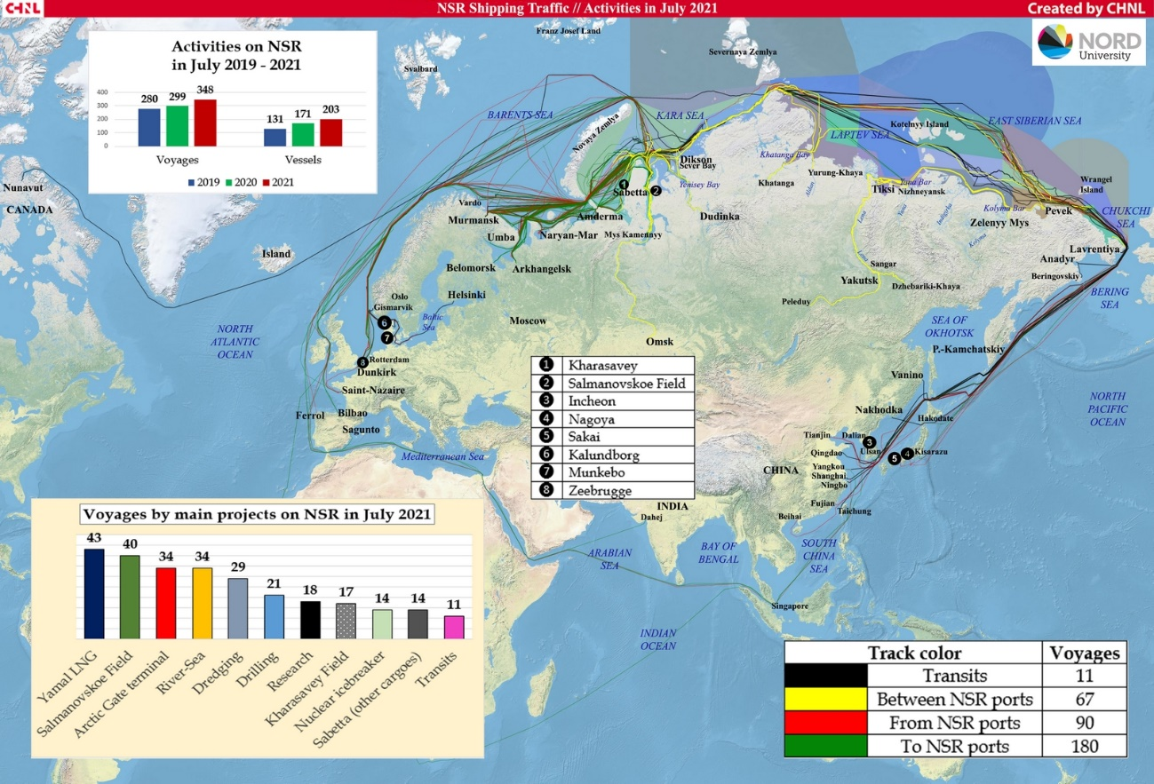

**Figure 1.2: Routes of vessels moving to and from terminals (existing and under construction) Ob Estuary in July 2021. Source: <https://arctic-lio.com/category/maps/>**

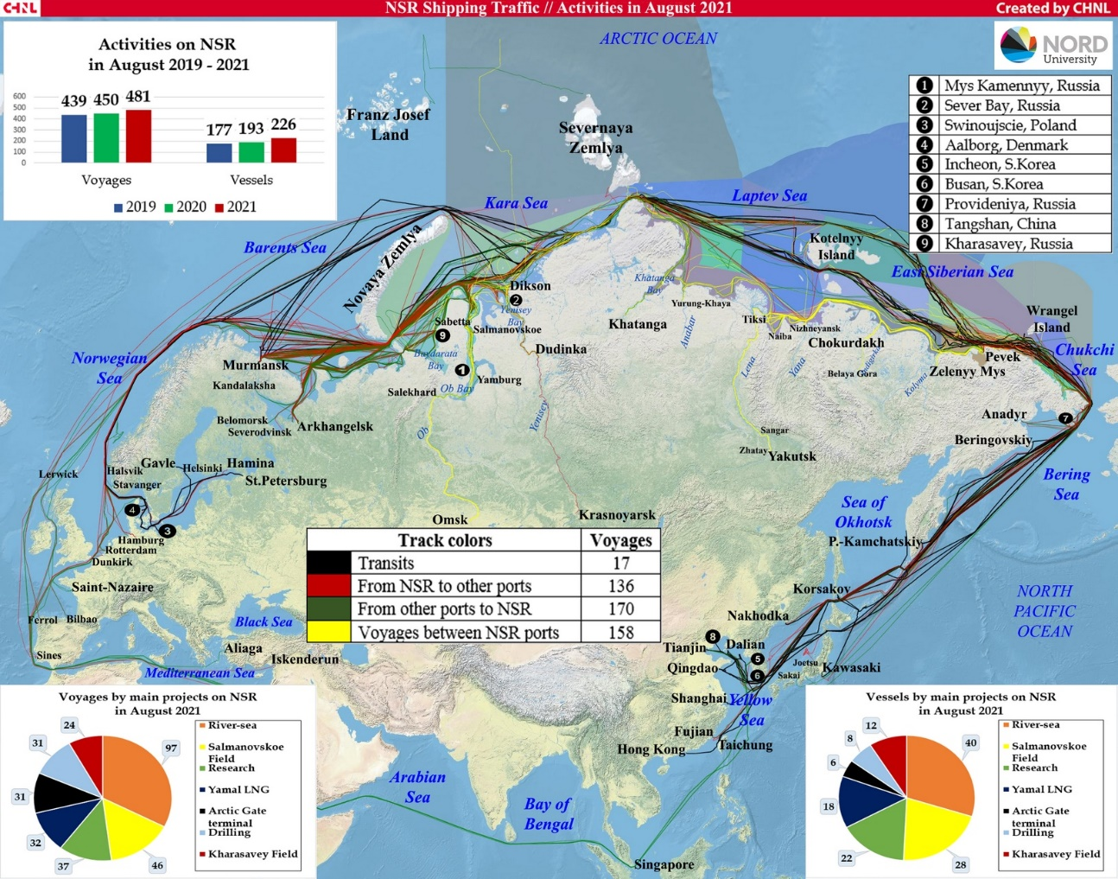

**Figure 1.3: Routes of vessels moving to and from terminals (existing and under construction) Ob Estuary in August 2021. Source: <https://arctic-lio.com/category/maps/>**

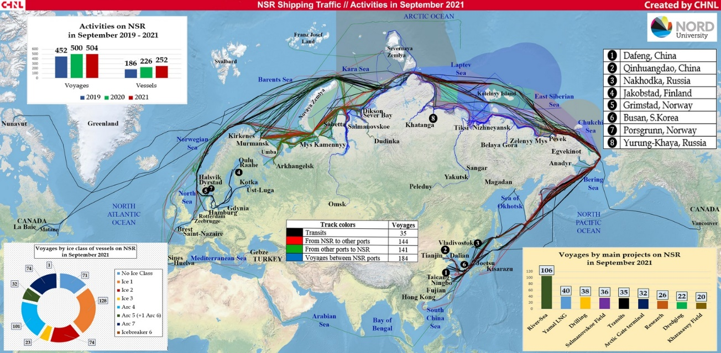

**Figure 1.4: Routes of vessels moving to and from terminals (existing and under construction) Ob Estuary in September 2021. Source: <https://arctic-lio.com/category/maps/>**

More than half of the export shipments in July and August 2021 went eastward – to China, Japan and South Korea (8 shipments out of 14), and 6 vessels went to Europe – to the Netherlands, Spain, Portugal and France (<https://arctic-lio.com/>). In 2020 main destination of LNG and gas condensate were European ports: Belgium (62 voyages), France (58), Netherlands (26), Spain (30), UK (22). There were 25 voyages in China.

The most likely route for NIS transfer is the western one, because all destination ports in Asia are situated further south than European ones. The most probable candidate seems to be Northern and Baltic Seas. Therefore, we further concentrate on organisms, which are documented as numerous and spreading their range in the northern Europe. We should keep in mind the increase of voyage number during the last three years and very probable preservation of this trend in future, which means increase of NIS load in the area of interest.

The total traffic has been increasing for the last three years, and this tendency will remain in future, because of development of new projects. The number of long-distance voyages will rise significantly as new fields and terminals are put into operation. Thus, the load of alien species will increase and probability of introduction invasive species will increase as well. However, introduction can be prevented by monitoring plankton and benthos and take effective measures to treat ballast water and fouling.

Arctic LNG2 is currently taking steps to minimize the risk of introducing alien species into its areas of operation. Key steps in this direction are as follows:

- strict adherence to the requirements of BWM Convention for the Project’s vessels. All LNG tankers will meet D2 standard;

- in charter contracts, the Company requires the vessel to comply with the requirements of the BWM Convention 2004; and of the International Convention on the Control of Anti-fouling Systems on Ships 2001;

- the Arctic LNG2, as well as the Yamal LNG, are monitoring the marine ecosystems of the Ob Estuary, aimed, among other things, at early detection of alien species.

Consequently in 2020-2021, hydrobiological studies were carried out aimed at identifying biological invasions in the northern part of the Ob Estuary. These included the sampling of plankton and benthos in the sea, the sampling of ballast water, and the study of fouling of berthing facilities.

As an example, in 29 November 2020 and 1 February 2021 investigations of ballast water of construction vessels in “Utrenniy” terminal area were conducted (Integrated investigations… 2020).[[10]](#footnote-11) 4 cargo ships, were surveyed, which operate according to plankton composition on the local routes (freight transportation from Murmansk and Arkhangelsk). 2-3 taxons of planktonic organisms were found: *Limnocalanus grimaldii* (Figure 1.4.1), *Pseudocalanus* spp., Calanoida naupliiin numbers up to 630 m-3. Many individuals were dead at the moment of sampling (up to 50%). It should be noted, that no NIS were found in ballast water samples in 2020 and 2021. Those were all cargo ships, operating, according to plankton composition, on the local routes. However, on long-distance routes situation may be absolutely different.

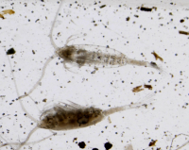

Figure 1.5: *Limnocalanus grimaldii* in samples of ballast water (Integrated investigations… 2020)

In October 2020 investigations of fouling on constructions of terminal “Utrenniy” were conducted as well. No real fouling was observed, because constructions were newly built. In the silt from vertical walls 50 species of microalgae were revealed from 5 taxonomic groups (Bacillariophyta, Cyanophyta, Chlorophyta, Euglenophyta, Cryptophyta). No animals were detected in samples. However, the process of fouling requires some time, and should be monitored continuously (see Recommendations).

### Terrestrial ecosystems

All 6 introduction pathways (CBD, 2014)[[11]](#footnote-13) were detected for non-native vascular plants within the Arctic territories, however but their participation varies in different floristic provinces (Wasowicz et al., 2020)[[12]](#footnote-14). The reason for the difference is the prevailing type of land use, the degree and human development history of the region, as well as the presence of different transport infrastructure (Dorogostaiskaya, 1972)[[13]](#footnote-15). The research area Yamal-Gydan sector of the Arctic until the end of the 20th century had a very low industrial development and was used as a natural pastures for reindeer. In recent decades, the construction of oil and gas infrastructure, related facilities has appeared here. Inevitably, the introduction of non-native vascular plant species began into human created and natural habitats. In accordance with Convention of Biological Diversity we detected 3 category of the pathways: release in nature, transport–contaminant and transport–stowaway.

Release in nature refers to the intentional introduction of live alien organisms for the purpose of human use in the natural environment. During the construction of plants and infrastructure often used restoration activities included biological stage for fixing the substrate and creating artificial meadows (Figure 1.4.5). Multi-component seed grass mixtures are usually used. The composition often contains species that can spread beyond the land allotment and form long-lived populations, *i.g.* *Elytrigia repens, Bromus inermis, Lolium perenne, Phleum pratense*, etc.

|  |  |
| --- | --- |
| D:\работа\Салмановское\фото\рекультивация\около 22-23\DSC_0955.JPG | D:\работа\Салмановское\фото\рекультивация\в районе точки 24\DSC_0914.JPG |

Figure 1**.**6**:** Cultivated meadow on restoration road embankments in the Gydan Peninsula. IEPI, 2020

Transport–Contaminant refers to the unintentional movement of diasporas as contaminants of a commodity. Within the study area, this is the most widespread introduction pathway of non-native plant species and it is associated with the formation of restoration sites. On the one hand, very low-quality seed material with an abundance of weed species is often used for sowing restoration areas. On the other hand, part of the diasporas can come with imported soil for the work. Within the Yamal-Gydan Arctic, the fertile layer is very small and not suitable for use; therefore, a significant part of the fertile soil is brought from more southern regions. As, these species are represented by common field weeds in more southern regions, *e.g.* *Chenopodium album, Galium spurium subsp. vaillantii, Potentilla intermedia*, etc.

Despite the harsh climatic conditions in the Arctic, there have been numerous attempts at farming. Within the Yamal-Gydan sector of the Arctic, no cultivation of agricultural crops was recorded, however, near its southern border in Dudinka from the end of 1930 a state farm and an agricultural experimental station were organized (Dorogostaiskaya, 1972). As a result, dozens of weed species were unintentionally introduced here with planting seed. We estimate the current impact on the area of assessment of this potential source of alien species dispersal as minimal due to absence of any roads.

Transport–Stowaway refers to the moving of plants attached to transporting vessels and associated equipment. The significant increase of traffic flows, the creation of seaports and airports has been a driver for the unintentional introduction of a number of species commonly associated with humans, e.g. *Juncus bufonius, Plantago major, Stellaria media, Trifolium repens, Urtica dioica*. At the same time, the process of introduction of species by this pathway by transport is relatively weak due to the lack of highways and railways connecting with other territories.

Thus, within the assessment area only three introduction pathways of non-native plant species were noted in accordance with the classifications of the Convention of Biological Diversity. They are associated with unintentional drift by man, luggage and equipment, as well as restoration activities using contaminated planting material.

## Limitations

The report aims to analyze the main pathways of introduction related to the transport activities of the Project and the transformation of terrestrial ecosystems on Gydan peninsula. The spatial scope of the assessment covers the Area of the Project’s Influence. This analysis does not cover in detail a number of groups of organisms that could potentially be alien to the region due to anthropogenic activities not related to the project, such as animal husbandry, acclimatization of mammals and fish for their fishery

# Assessment Methodology

## Marine biota

### General Scheme of Analysis

Our approach is close to that implemented in Goldsmit et al 2020[[14]](#footnote-18). However, in the face of scarcity of hydrobiological data, we had to significantly simplify the approach.

A monitoring system is needed to reliably predict the risks of alien species introduction. There is no such system in the described water area yet. Historical data on the marine biota of the Gulf of Ob are very fragmentary and do not provide a basis for constructing an analysis like that presented in Goldsmit et al 2020. Therefore, the only possible way is a meta-analysis of published data.

The applied approach is simple in its methodology and can be verified. The approach is based on four key positions:

1. Description of the ecological permits of the water area (i.e. ecological licenses of the area in the sense of Ozersky, 2011).

2. Identification of the most complete set of species potentially capable of invasion.

3. Estimation of parameters of ecological niches of potential invasive species.

4. Filtering the list of species by comparing their niches and the ecological permits of the area.

Therefore, some cautions should be announced about the approach we applied.

First, our task was to generate a list of expected alien species. That is, our analysis only provides information about which species might be expected as NIS, but not provide any evidences of invasions. Thus, our analysis cannot provide reliable information about which species already in the area are recent invasive species. We can only build some hypotheses about it.

Second, we cannot make any decision about when and how this expected NIS will be introduced into the area of project: would it be made through ballast water of through hull bio-fouling.

Third, our approach cannot predict which native species of the Ob Estuary could potentially be exported outside the area and thus become invasive species in other areas where ship traffic will be organized to.

And finally, our approach is based on the analysis of ecological permits of the Ob Estuary (described in terms of water salinity and temperature). The later can change due to some global change processes. We considered conditions expanded in compare with the observations (e.g. temperature range was taken broader than the range observed). Thus some changes potentially associated with ocean warming were implicitly included in our analysis. However, we can not warrant of absence of any other scenarios of NIS introduction basing on unexpected changes of ecological permits of the area (e.g. due to antropogenic changes in hydrological conditions in the region).

Information on native species of benthos and zooplankton was taken from “Integrated investigations…” (2020). Native species involved in the analysis included those forms that were determined to species level (or in cases of presumed cryptic species, to genus). We considered only those species which were found and abundant in benthic and plankton surveys in the estuarine portion of the water area (at stations south of 73 degrees N). Pure marine species, represented mainly in the northern part of the water area, were not included in the analysis. We declined to include in the analysis purely marine species because their penetration into the areas of interest is impossible due to the very low salinity. Although the introduction of marine species is theoretically possible in the northernmost parts of the region.

The *Invasive Species in Russia* database (<http://www.sevin.ru/top100worst/index.html>) was used to identify PNIS among benthic forms. Several species mentioned as potential invasive species in Arctic waters (Goldshmit et al. 2020) were included in the analysis as well.

Analogously several planktonic species referred as invasive species in *Invasive Species in Russia* database (<http://www.sevin.ru/top100worst/index.html>) were included in our analysis. However, since only few forms were mentioned in this database, the additional search for potential NIS was accomplished as follows. As it was shown above, the most probable way of introduction of NIS is western Europe. We analyzed the plankton fauna of estuaries of the western Europe, where the most destination ports are situated. We chose eurybiont species with the most northward range, which were then included in analysis of potential NIS in the Ob Estuary.

Additionally, one species (planktonic copepod *Acartia bifilosa*) which is referred as abundant element of season planktonic community of the White and Baltic seas was included in the analysis since the conditions in these seas can be similar to Ob Estuary. This species was not included in the *Invasive Species in Russia* database. However, another species, *Acartia tonsa*, is referred there. Since taxonomic disagreements are highly possible in the case of plankton identification we included both species in the analysis.

### Analysis of geographic distribution of hydrobionts

In the summarized list of benthic and planktonic species (165 species), each of them was labeled as “Native” or “PNIS.” Next, for each species, the Global Biodiversity Information Facility database (<https://www.gbif.org/>) was queried to find the geographic localities where the species was occured. Only unique combinations of latitude and longitude were considered. A Geographic Dataset (GDS) was generated from these queries (266725 unique localities were included).

The GDS was used to analyze the latitudinal distribution of species. This analysis compared the latitudinal range limits of native species and PNIS. This analysis is designed to screen out those PNIS whose distribution centers are far from the geographic boundaries of the analyzed water area. The following values were calculated from the GDS and considered as biogeographic characteristics of the species.

- the median of latitude values. It is assumed that this value characterizes the “core” of the latitudinal range.

- Maximum value of latitude, at which the species was occured

- value of 2.5% quantile of latitude

- value of 97.5% of the quantile of latitude

- the ratio of the number of localities with latitude above the Arctic Circle to the total number of encounters. It is assumed that the higher this value, the more likely this species is found in the Polar region.

- the value of asymmetry in the distribution of latitude values. It is assumed that the more asymmetric the distribution, the more pronounced is the tendency of displacement of the species from the range.

- value similar to the previous one. It is the ratio of the distance from the median of latitude to Q\_low to the distance from the median to Q\_up. The logathmic transformation was applied to make the values distributed in range between 0 and 1 more pronounced.

$$Asymmetry=ln(\frac{|Q_{up}−M|}{|Q_{low}−M|})$$

The matrix of these variables was used in principal component analysis (PCA). The score of PC1 was used for a general assessment of latitudal species distribution.

### Assessment of environmental parameters

For all species included in the analysis (Native and PNIS), salinity and temperature values at their occurrence (GBIF) points were estimated. Bio-ORACLE (<https://bio-oracle.org/>; Tyberghein et al. 2021; Assis et al. 2017)[[15]](#footnote-20),[[16]](#footnote-21) was used to estimate hydrological parameters in marine areas. Sea water salinity (mean at mean depth) and sea water temperature (mean at mean depth) were extracted from this GIS for each occurrence point. Because some of the geographic locations of the species occurrence were in freshwater areas, temperature data were additionally searched using EarthEnv data portal (<http://www.earthenv.org/streams>; Domisch et al., 2015).[[17]](#footnote-22) For the locations whose parameters were estimated using the EarthEnv GIS, the salinity value was assumed to be zero.

### Statistical analysis

All data processing was performed with functions of R statistical programming language (R Core Team, 2021).[[18]](#footnote-23)

The queries for GBIF were performed with package “spocc” (Scott, Chamberlain, 2021)[[19]](#footnote-24). The verification of taxonomic characteristics of species was processed with the package “worms” (Holstein, 2018)[[20]](#footnote-25) retriving the information from WoRMS data base (<https://www.marinespecies.org/>).

Principal component analysis was performed with the package “vegan” (Oksanen et al. 2020)[[21]](#footnote-26).

## Terrestrial biota

### Data resources on vascular plants

To prepare a list of alien terrestrial plant species and assess their invasive status, a study area was include the Yamal and the Gydan Peninsulas and areas adjacent to them from the south, up to the southern border of the Arctic in accordance with Circumpolar Arctic Vegetation Map (Walker, 2005)[[22]](#footnote-27). This territory corresponds to Yamal-Gydan floristic province (Yurtsev, 1994)[[23]](#footnote-28) or sector (Elvebakk et al., 1999)[[24]](#footnote-29). This territory contrasts with adjacent area in terms of a low native floristic richness in association with various negative features of its flora: the gap in the distribution areas of many montane, predominantly East Siberian species; the absence of scores of 'eastern' (trans-Yenisey) species along with western ones (European, amphi-Atlantic, etc.) reaching the Ural Mts. Many 'western' species are confined to the lower Ob drainage up to the Taz Peninsula, and are lacking in the Gydan Peninsula; some of them are also recorded outside the Arctic from the mountains on the right bank of the Yenisey River. Most of the western elements of native flora are restricted to the southernmost areas whereas the role of the eastern counterparts increases northwards (Yurtsev, 1994).

To characterize the composition of the non-native vascular flora of the Yamal-Gydan Arctic, we consulted diverse data sources. In preparing the check-list species of the study area, we used reference books as Arctic flora of the USSR (Tolmachev, 1960-1975; Tolmachev, Yurtzev, 8; Yurtzev, 1984-1897)[[25]](#footnote-30), Flora of the Yamal Peninsula (Rebristaya, 2013)[[26]](#footnote-31), comprehensive review on non-native vascular flora of the Arctic (Wasowicz et al., 2020), as well as we provide a scope a species records on huge corpus of Russian grey literature (Rebristaya, 1999[[27]](#footnote-32); Kniazev, Morozova, 2006[[28]](#footnote-33); Kniazev et al., 2006[[29]](#footnote-34); Rebristaya, 2006[[30]](#footnote-35); Pismarkina, 2014[[31]](#footnote-36);Byalt, Egorov, 2019[[32]](#footnote-37);Pismarkina, 2019[[33]](#footnote-38); Pismarkina, Bystrushkin, 2019[[34]](#footnote-39); articles with absence new records to the territory were excluded) and study ecological engineering surveys and monitoring by FRECOM[[35]](#footnote-40) on the South-Tambey LA and IEPI on Salmanovskiy (Utrenniy) LA[[36]](#footnote-41). To georeference clarify of a number of localities of alien species and to determine their position in relation to the Arctic according to CAFF we used digital representation of specimens in Digital herbarium of Moscow State University (MW) and Komarov Botanical Institute RAS (LE). Mainly, this concerns the herbarium collection of P.Yu. Zhmylev and S.N. Elanosky collected in 1992: a lot of floristic records have not yet been published. A number of ambiguous plant species records for Yamal LNG conducted by FRECOM, were excluded from the final check-list. In particular *Chamaenerion angustifolium* is erroneously listed as an non-native species. A number of ambiguous records for Yamal LNG by FRECOM company, were excluded from the final check-list. This species rarely occurs in the middle part of the Yamal Peninsula, but it can actively populate disturbed territories as in other northern regions. Some species indicated in publications were also excluded from the check-list: *Achillea asiatica* Serg., *Erigeron acris* L. s.l., *Agrostis clavata* Trin. (Byalt, Egorov, 2019), *Achillea salicifolia* Besser ex DC., *Lactuca sibirica* L. (Pismarkina, 2014), and *Myosotis laxa* subsp. *caespitosa* (C.F. Schultz) Nordh. (Wasowicz et al., 2020). They are also native species actively colonize disturbed habitats.

We provide the attempt to classify non-native taxon according to their invasion status as ‘casual’ or ‘naturalized’ (Richardson et al. 2000[[37]](#footnote-42)). We used the pathway categorization accepted by the Convention of Biological Diversity (CBD 2014).

To preparation of maps the ranges and distributional suitability modeling to potentially invasive species in the Yamal-Gydan sector of the Arctic was used extent area from Svalbad to Yenisey River boarding from south by the Arctic Circle. We accumulate species occurrences from previous citied literature and manuscripts, comprehensive databases Global Biodiversity Information Facility (https://www.gbif.org/), Artsdatabanken (https://www.artsdatabanken.no/), Artportalen (https://www.artportalen.se/), Finnish Biodiversity Information Facility (https://www.laji.fi/) and herbarium collections of Moscow State University (MW) (https://plant.depo.msu.ru/) and Komarov Botanical Institute RAS (LE) (https://herbariumle.ru/).

### Species distribution modelling

To assess the current “place“ of the potentially invasive plant on the Yamal-Gydan region and it’s change in future, we built species distribution models for six species. The aim of niche-based species distribution modelling approach is to estimate the similarity of the environmental conditions at any site to the conditions at the locations of known occurrences of a target species and is to predict species ranges and relative habitat suitability in geographical space (Elith, Leathwick 2009)[[38]](#footnote-43). For these purposes we use all localities of *Anthriscus sylvestris, Bromus inermis, Elymus repens, Stellaria media, Trifolium repens* and *Urtica dioica* from GBIF and publications cited in the section above.

In order to provide a sufficient number of plant localities for modelling, we chose as the extent the area of the western Arctic, limited 66.5˚-81˚N, 10˚-89˚N (Figure 2. 1).

To avoid spatial segregated localities we filtered occurrence data and removed records closer to each other than 50km. Since herbarium data is spatially biased (flora in some areas is much more better documented than in others), the background points was collected at 50 km buffer for all plant localities in the modelling extent.

As predictors we used CHELSA “bioclimatic” variables (Karger et al. 2017)[[39]](#footnote-44). We resampled resolution of climate data to 5\*5 km. All operations with the spatial raster data were performed in “raster” package[[40]](#footnote-45). We used *Asia North Albers Equal Area Conic* projection.

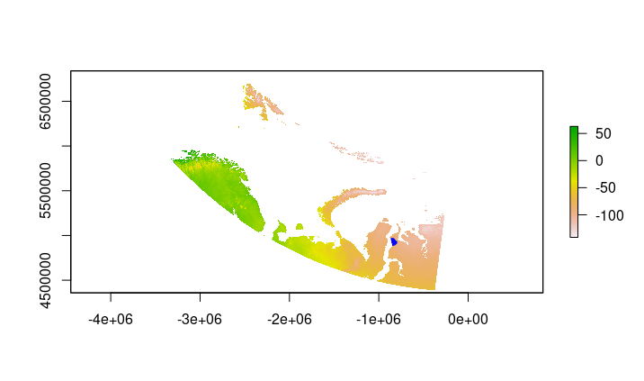

**Figure 2.1:** **Extent for species distribution modelling. Blue dots on the Salmanovskiy (Utrenniy) LA used for the analysys of habitat suitability change in future. Prepared by Consultant**

To avoiding the collinearity in environmental dataset (Dormann et al., 2012)[[41]](#footnote-49) we selected variables using pairwise correlation coefficient and the variance inflation factor (VIF) (Marquardt 1970)[[42]](#footnote-50). We selected variables with Pearson correlation coefficient less than 0.7 and a VIF less than 10. For this calculation we used “usdm” package (Naimi et all., 2014[[43]](#footnote-51)) implemented in R statistical programming language (R Core Team, 2021).

The final set included 6 variables:

*bio\_1* - mean annual air temperature;

*bio\_8* - mean daily mean air tempertures of the wettest quarter;

*bio\_9* - mean daily mean air tempertures of the driest quarter;

*bio\_15* - precipitation seasonality;

*bio\_19* - mean monthly precipitation amount of the warmest quarter;

*gsp* - Accumulated precipiation amount on days above 0˚C.

To estimate the changes of species distribution in future we used The CHELSA CMIP5 timeseries for 2041-2070. We used four models (GFDL-ESM4, MPI-ESM1, MRI-ESM2-0, UKESM1-0-LL) and three scenario: SSP126, SSP370, SSP585 for each model[[44]](#footnote-52).

We used Maxent approach (Phillips, Dudik 2008[[45]](#footnote-53); Phillips et al., 2017[[46]](#footnote-54)) for modelling. To minimize sampling bias and model overfitting effects we use spatial jackknifing (k-fold cross-validation) (Shcheglovitova, Anderson 2013[[47]](#footnote-55); Radosavljevic, Anderson 2014[[48]](#footnote-56)). Implementation of this approach in “ENMeval” package (Kass et al., 2021[[49]](#footnote-57)) in R also allows to choose experimentally the optimal model complexity parameters as regularization and feature classes that strongly affect the final model (Merow et al. 2013[[50]](#footnote-58)). We tuned models using "L","LQ","LQH" feature sets and 1:3 regularization multipliers. The best model was selected automatically as the model with the lowest AICc (Akaike information criteria; Warren & Seifert, 2011[[51]](#footnote-59)). 10000 background points we used. To estimate the level of predicted suitability we used two threshold values “maximum training sensitivity and specificity threshold” and “X10.percentile.training.presence” (Liu et al. 2013)[[52]](#footnote-60).

# Assessment Results

## Marine environment

### Hydrological conditions in the Ob Estuary

The hydrological model (**INMOM**) was a source of information to describe hydrological conditions in the Ob Estuary.

The hydrodynamic model was built on the basis of the well-tested Russian universal three-dimensional σ-model of marine and oceanic circulation INMOM (Institute of Numerical Mathematics Ocean Model), which was created at the Institute of Computational Mathematics of the Russian Academy of Sciences (INM RAS). The hydrodynamic model was built on the basis of the well-tested Russian universal 3D σ-model of marine and ocean circulation INMOM (Institute of Numerical Mathematics Ocean Model), which was created at the Institute of Computational Mathematics of the Russian Academy of Sciences (INM RAS)[[53]](#footnote-61). It should be noted that the complex vertical structure of the currents of the Gulf of Ob makes it practically impossible to use simplified two-dimensional models for calculating the thermohydrodynamic characteristics of the bay without taking into account the density stratification, even despite its relative shallowness. To correctly reproduce the density stratification of the Gulf of Ob, the use of three-dimensional hydrothermodynamic models is fully justified.

The INMOM model has proven itself well in solving practical problems of calculating hydrological characteristics in various parts of the seas of Russia, as well as in the framework of participation in international projects. Global versions of INMOM serve as oceanic blocks in various versions of the Institute of Numerical Mathematic Climate Model (INMCM) earth system model[[54]](#footnote-62), created at the INM RAS and participating in the climate change forecasting program under the auspices of the IPCC (Intergovernmental Panel on Climate Change) within the framework of CMIP projects (Coupled Model Intercomparison Project). The INMOM model also took part in the CORE II (Coordinated Ocean-ice Reference Experiments, phase II) program to study the circulation of the World Ocean and its variability based on a multi-model approach[[55]](#footnote-63).

The INMOM model was successfully used to study the circulation of the western seas of the Russian Arctic, including the Gulf of Ob, and other seas of the Russian Federation[[56]](#footnote-64)[[57]](#footnote-65)[[58]](#footnote-66)[[59]](#footnote-67)[[60]](#footnote-68).

Thus, when implementing the INMOM model for the purposes of this work, two versions of it were developed and prepared:

1. version of the model for calculating thermohydrodynamic characteristics in natural conditions with the built sea channel in 2015;

2. version of the model for calculating thermohydrodynamic characteristics in the presence of hydraulic structures, dredging works, an approach channel and ice protection structures (LZS), and an extended and deepened approach channel to the port of Sabetta in the northern part of the Ob Bay.

To verify the INMOM model, data from surveys carried out in the area of the Arctic LNG 2 Project and the Sea channel in the northern part of the Gulf of Ob were used. Measurement data of current velocities and sea level were obtained from the Customer. Data cover the period from 2012 to 2020, excluding 2014, 2016, 2018, 2019. Measurements were carried out mainly in spring, summer and autumn.

The model made it possible to consider values of two key hydrological parameters (water temperature and salinity) in areas located in the vicinity of the currently operating port, “Sabetta,” and the port under design, Terminal “Utrenniy” (Figure 3.1.1).

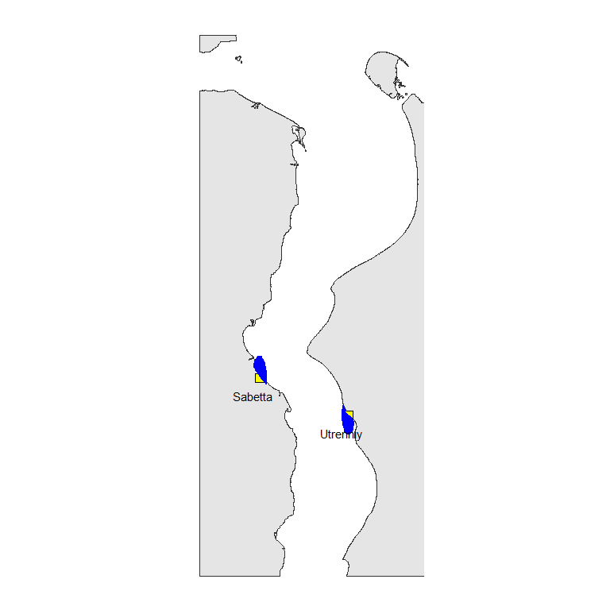

**Figure 3.1: Position of ports in the Ob estuary. Blue area marks a set of points nearest to ports selected for analysis of variation in hydrological parameters calculated by INMOM model. Prepared by Consultant**

Temperature and salinity in the area experience seasonal and annual fluctuations (Figure 3.1.2). The highest salinity is observed in spring, when the saline water tongue goes far upstream.

Water temperature values increase as the distance from the mouth of the Gulf of Ob upstream increases (Figure 3.1.3).

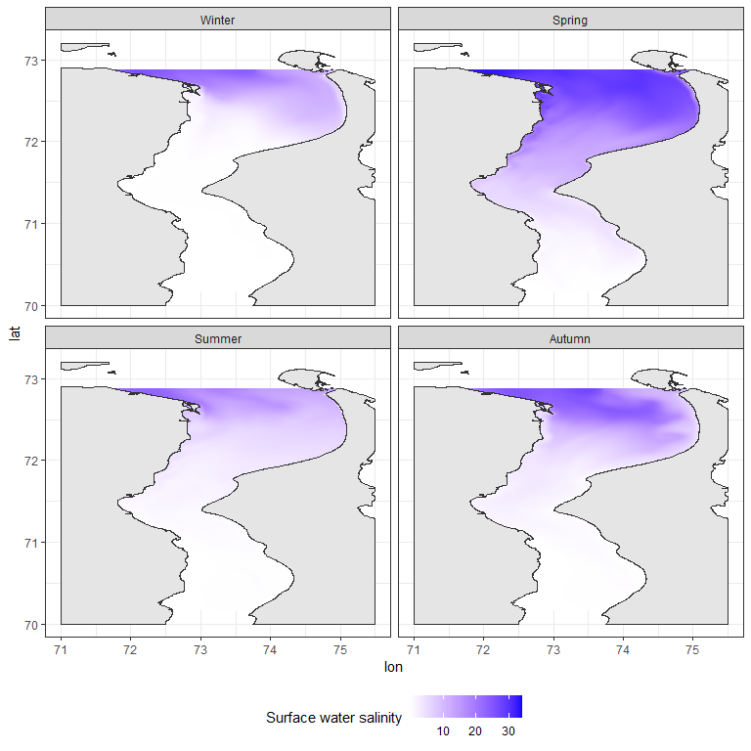

**Figure 3.2: Salinity in the Ob estuary in four seasons. Prepared by Consultant**

7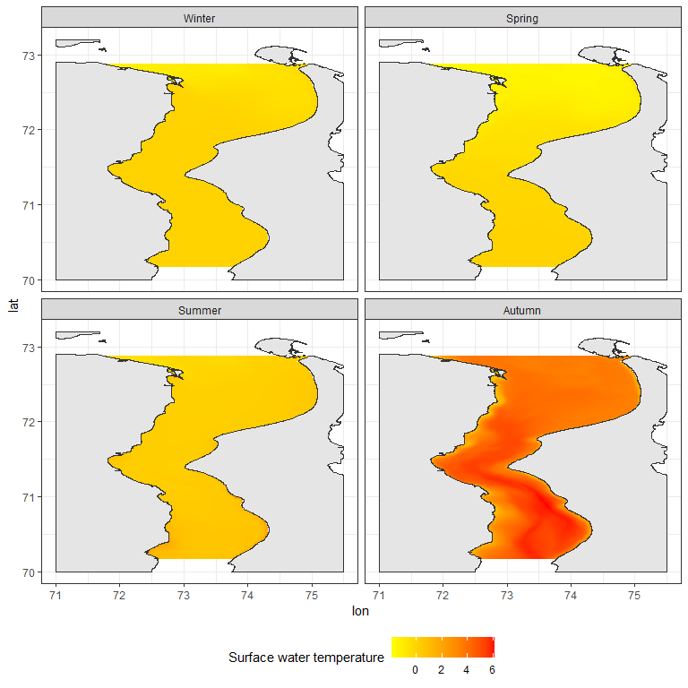

**Figure 3.3: Surface temperature in the Ob estuary in four seasons. Prepared by Consultant**

Model predictions were made for 796 points located in the areas adjacent to the ports (Figure 3.1.4). For these points, salinity and water temperature values were calculated for each day of the calendar year for five depth levels (0, 5, 10, 15, and 20 meters). In the further analysis, the average value of salinity and temperature calculated for each point was used.

T-S diagrams (Figure 3.1.4) show that cold, saline water is present in the port area in winter and spring. Salinity during this period varies within 0, 13 ppm and temperature within -0.5, 1.6 degrees.

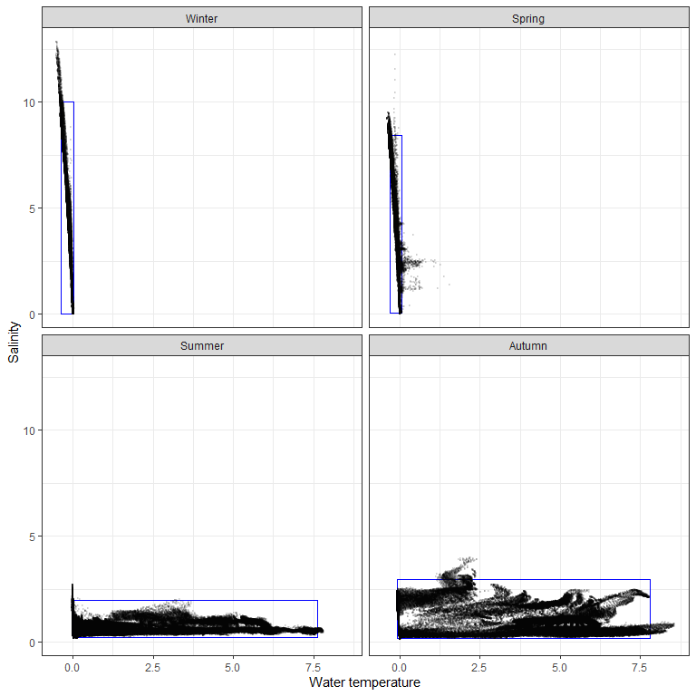

**Figure 3.4: T-S diagram reflecting limits of salinity and temperature variation in the area of ports in different seasons. Prepared by Consultant**

During the summer and fall salinity is low but there is considerable warming of the water in these seasons. During these periods salinity varies within 0.1, 4 ppm and temperature: -0.1, 8.6 degrees.

To describe the boundaries of the ecological license of the biotope that could potentially be inhabited by NIS, the salinity and temperature limits in the water area adjacent to the port areas were calculated as values of 0.5% and 99.5% quantiles of each of the parameters. In the Figure 3.1.4, these limits are indicated by rectangles.

The boundary of ecological license is the hydrological conditions that can be inhabited by PNIS. The port area seems to be the most likely areas for NIS invasion. However, according to climate change projections (<https://interactive-atlas.ipcc.ch/>), ocean surface temperatures will gradually increase in the Russian Arctic region (about 2 degrees per century). Hence, the boundaries of the ecological license along the temperature axis will shift towards higher temperatures, which will expand the possibility of NIS invasion in the future.

The warmest water mass is present in the water area during the autumn period. Thus this is a season that should be considered as the most dangerous in terms of the probability of introducing species from temperate latitudes.

It should be emphasized that any anthropogenic temperature increase will increase the likelihood of NIS invasion.

### Biogeographical analysis of potential planktonic and benthos NIS in marine realms

Using available datasets we found rather large amount PNIS between benthic animals but only few one between zooplankton (Table 3.1). However controversy situation was found between native forms.

**Table 3.1: Number of native and potentialy Non-indigenous speciesinvolved in the biogeografical analysis for benthic and planktonic animals**

|  |  |  |
| --- | --- | --- |
| Group | Native | PNIS |
| Benthos | 13 | 49 |
| Plankton | 95 | 8 |

The first principal component describing 81.7% of the total variation in species biogeographic characteristics shows a high negative correlation with the southern species distribution boundary ($Q_{low}$), median latitude ($Median_{lat}$) and northern species distribution boundary ($Q_{up}$). Thus, PC1 values can be interpreted as a latitudinal gradient in species distribution. Smaller values of PC1 correspond to higher latitudes.

It can be observed that native forms of benthos have a slightly more northern distribution than native planktonic forms. The latitudinal core of distribution of potential NIS involved in the analysis is shifted southerly in both benthic and planktonic potential invaders.

If we consider the value of the 95% quantile of PC1 as the southern boundary of native species distribution (vertical lines in Figure 3.1.5), then among benthic species 49 falls into number of species whose ranges are close to native species, but among planktonic only 8 species distributed closely to with native zooplankton species. Biogeographic characteristics of potential NIS are given in Table 3.2.

For all species included in the analysis (both Native and PNIS), salinity and temperature values at their occurence localities, taken from the GBIF database, were estimated. Bio-ORACLE and EarthEnv were used to estimate hydrological parameters in points of species occurrences.

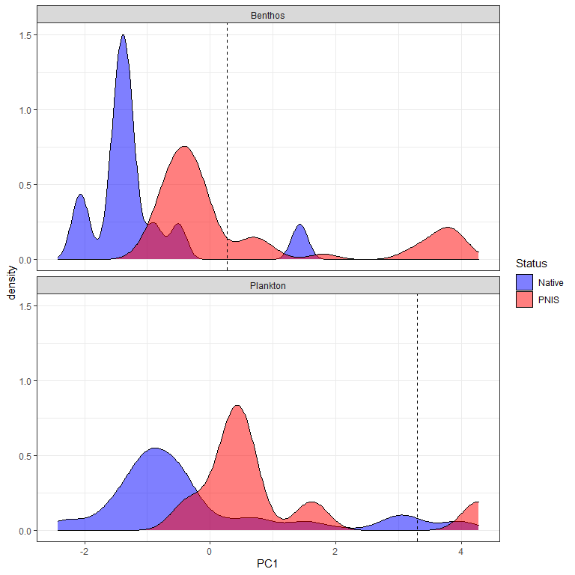

**Figure 3.5: Frequency distribution of PC1 scores for native and PNIS between benthic and planktonic species. Prepared by Consultant**

The area of maximum concentration of points corresponding to native species of benthos organisms agrees very well with the boundaries of the ecological license of the Ob estuary. Salinity values in the range of 0-10 ppm and 0-10 degrees can be considered as conditional niche boundaries for native benthos species. In the case of native plankton species some points also presented inside these boundaries. However, the maximum concentration of points, although falling within the cold-water range (less than 10 degrees), falls within ranges of the normal oceanic salinity.

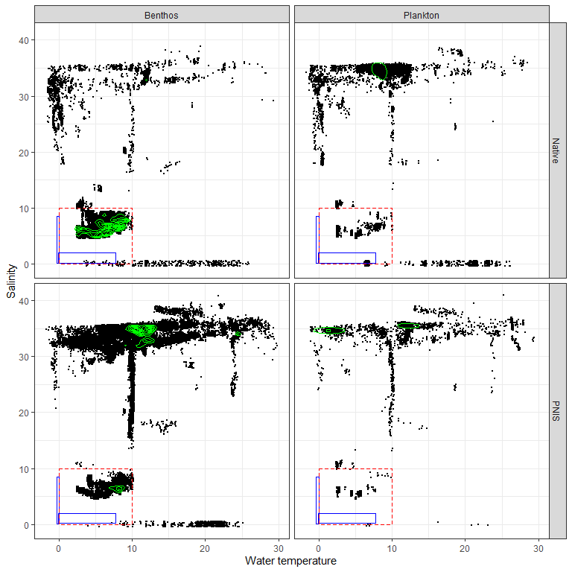

**Figure 3.6: Occurence of benthic and planktonic native species and PNIS in different hydrological conditions. The boundary of ecological license of Ob estuary in cold and warm seasons are represented by blue rectangles. The red rectangles reflect expanded ecological license. Green lines reflects areas with maximal point density. Prepared by Consultant**

To quantify the probability of PNIS colonization in the conditions of the Gulf of Ob, we introduced the value $P_{inv}$. To calculate this estimate, we calculated the number of locations obtained from the GBIF database for which the salinity-temperature conditions approximately corresponded to the ecological license of the Gulf of Ob (Salinity:0-10 ppm, Temperature 0-10 degrees). This value was divided by the total number of locations (for this species in the GBIF database) for which salinity and temperature were assessed. Values are given in the Table 3.2.

Table 3.2: Native species and PNIS for the Ob estuary ecosystem involved in analysis. Biogeographical characteristics: $Q_{low}$- 2.5% quantile of latitude, - median of latitude, - 97.5% quantile of latitude. - number of references in GBIF with environmental parameters inside the ecological license of the Ob estuary. $N_{total}$- total number of references with salinity and temperature assessed. $P_{inv}$-assessment of invasion probability

| **Status** | **Species** | **Group** | $$Q_{low}$$ | $$Median_{lat}$$ | $$Q_{up}$$ | $$N_{env}$$ | $$N_{total}$$ | $$P_{inv}$$ |
| --- | --- | --- | --- | --- | --- | --- | --- | --- |
| Native | *Bosmina kessleri* | Plankton | 61.8 | 62.0 | 62.0 | 3 | 3 | 1.000 |
| Native | *Monoporeia affinis* | Benthos | 56.0 | 60.2 | 65.7 | 8318 | 8461 | 0.983 |
| Native | *Saduria entomon* | Benthos | 55.8 | 60.4 | 69.6 | 6061 | 6351 | 0.954 |
| Native | *Halicryptus spinulosus* | Benthos | 55.2 | 58.3 | 60.6 | 3149 | 3315 | 0.950 |
| Native | *Marenzelleria* | Benthos | 39.2 | 59.2 | 64.6 | 6664 | 7087 | 0.940 |
| Native | *Mysis relicta* | Benthos | 45.1 | 62.9 | 70.1 | 540 | 666 | 0.811 |
| Native | *Pontoporeia femorata* | Benthos | 54.8 | 58.7 | 72.0 | 1410 | 1739 | 0.811 |
| Native | *Bosmina coregoni* | Plankton | 53.7 | 63.5 | 65.7 | 237 | 324 | 0.731 |
| Native | *Daphnia cristata* | Plankton | 58.7 | 60.6 | 69.4 | 149 | 215 | 0.693 |
| Native | *Keratella quadrata* | Plankton | 37.3 | 61.8 | 65.7 | 411 | 626 | 0.657 |
| Native | *Keratella cochlearis* | Plankton | -0.5 | 61.8 | 65.7 | 393 | 619 | 0.635 |
| Native | *Bosmina maritima* | Plankton | 55.0 | 57.3 | 58.8 | 4 | 7 | 0.571 |
| Native | *Limnosida frontosa* | Plankton | 55.3 | 59.7 | 62.0 | 6 | 11 | 0.545 |
| Native | *Limnocalanus macrurus* | Plankton | 59.6 | 63.5 | 74.4 | 379 | 732 | 0.518 |
| Native | *Daphnia cucullata* | Plankton | 49.7 | 53.0 | 65.2 | 37 | 85 | 0.435 |
| Native | *Eurytemora affinis* | Plankton | 30.9 | 51.3 | 65.7 | 84 | 217 | 0.387 |
| Native | *Thermocyclops oithonoides* | Plankton | 51.0 | 59.4 | 65.3 | 39 | 101 | 0.386 |
| Native | *Kellicottia longispina* | Plankton | 33.6 | 52.1 | 64.3 | 20 | 73 | 0.274 |
| Native | *Trichocerca porcellus* | Plankton | 18.8 | 47.5 | 62.0 | 3 | 11 | 0.273 |
| Native | *Notholca caudata* | Plankton | 45.8 | 46.1 | 58.1 | 1 | 4 | 0.250 |
| Native | *Cyclops strenuus* | Plankton | 40.1 | 51.2 | 61.2 | 3 | 14 | 0.214 |
| Native | *Biapertura affinis* | Plankton | -32.2 | 19.8 | 56.9 | 1 | 5 | 0.200 |
| Native | *Eurytemora hirundoides* | Plankton | 40.6 | 54.1 | 59.4 | 2 | 10 | 0.200 |
| Native | *Trichocerca capucina* | Plankton | 18.3 | 48.9 | 62.0 | 3 | 15 | 0.200 |
| Native | *Moina macrocopa* | Plankton | 19.2 | 50.7 | 61.8 | 4 | 22 | 0.182 |
| Native | *Eurycercus lamellatus* | Plankton | 50.6 | 60.0 | 69.6 | 60 | 339 | 0.177 |
| Native | *Notholca acuminata* | Plankton | 43.5 | 51.9 | 62.0 | 3 | 17 | 0.176 |
| Native | *Leptodora kindti* | Plankton | 50.1 | 59.7 | 68.2 | 17 | 116 | 0.147 |
| Native | *Synchaeta pectinata* | Plankton | -41.8 | 45.4 | 62.0 | 3 | 21 | 0.143 |
| Native | *Podon leuckarti* | Plankton | 33.0 | 62.7 | 70.6 | 32 | 226 | 0.142 |
| Native | *Sida crystallina* | Plankton | 50.6 | 59.8 | 69.2 | 37 | 281 | 0.132 |
| Native | *Diacyclops bisetosus* | Plankton | 38.9 | 51.1 | 60.0 | 1 | 8 | 0.125 |
| Native | *Limnodrilus hoffmeisteri* | Benthos | 4.7 | 51.9 | 60.5 | 176 | 1411 | 0.125 |
| Native | *Paracyclops fimbriatus* | Plankton | -26.1 | 59.6 | 69.1 | 4 | 36 | 0.111 |
| Native | *Euchlanis dilatata* | Plankton | -27.9 | 32.9 | 61.9 | 3 | 28 | 0.107 |
| Native | *Mesocyclops leuckarti* | Plankton | 50.0 | 59.7 | 64.7 | 15 | 147 | 0.102 |
| Native | *Bosmina longirostris* | Plankton | -0.6 | 52.2 | 65.7 | 19 | 192 | 0.099 |
| Native | *Brachionus calyciflorus* | Plankton | -25.7 | 45.3 | 62.0 | 7 | 74 | 0.095 |
| Native | *Megacyclops viridis* | Plankton | 42.1 | 59.6 | 69.6 | 7 | 74 | 0.095 |
| Native | *Eurytemora lacustris* | Plankton | 51.4 | 52.2 | 60.1 | 1 | 11 | 0.091 |
| Native | *Polyarthra dolichoptera* | Plankton | -25.7 | 51.7 | 61.8 | 3 | 34 | 0.088 |
| Native | *Diacyclops bicuspidatus* | Plankton | 40.1 | 51.3 | 60.9 | 2 | 23 | 0.087 |
| Native | *Alona quadrangularis* | Plankton | 43.8 | 52.6 | 69.2 | 5 | 58 | 0.086 |
| Native | *Heterocope appendiculata* | Plankton | 59.3 | 62.6 | 71.9 | 3 | 47 | 0.064 |
| Native | *Asplanchna priodonta* | Plankton | 42.6 | 54.3 | 69.6 | 6 | 97 | 0.062 |
| Native | *Acanthocyclops vernalis* | Plankton | 24.6 | 58.8 | 69.5 | 3 | 50 | 0.060 |
| Native | *Filinia longiseta* | Plankton | -24.6 | 45.9 | 63.4 | 4 | 73 | 0.055 |
| Native | *Brachionus angularis* | Plankton | -1.4 | 38.8 | 53.3 | 4 | 74 | 0.054 |
| Native | *Daphnia galeata* | Plankton | 42.5 | 60.1 | 69.5 | 8 | 162 | 0.049 |
| Native | *Daphnia pulex* | Plankton | 19.4 | 51.2 | 74.3 | 6 | 129 | 0.047 |
| Native | *Ceriodaphnia pulchella* | Plankton | 49.7 | 53.2 | 68.9 | 3 | 92 | 0.033 |
| Native | *Bosmina longispina* | Plankton | 58.1 | 60.6 | 69.7 | 3 | 143 | 0.021 |
| Native | *Bythotrephes longimanus* | Plankton | 42.4 | 60.1 | 69.3 | 3 | 144 | 0.021 |
| Native | *Eudiaptomus gracilis* | Plankton | 51.1 | 58.8 | 69.5 | 4 | 203 | 0.020 |
| Native | *Macrocyclops albidus* | Plankton | 18.1 | 59.9 | 69.7 | 7 | 346 | 0.020 |
| Native | *Ceriodaphnia reticulata* | Plankton | 9.3 | 51.3 | 61.5 | 1 | 57 | 0.018 |
| Native | *Chydorus sphaericus* | Plankton | 35.9 | 58.6 | 69.2 | 9 | 495 | 0.018 |
| Native | *Eucyclops serrulatus* | Plankton | 39.3 | 60.3 | 69.9 | 6 | 356 | 0.017 |
| Native | *Daphnia longispina* | Plankton | 0.3 | 59.8 | 69.1 | 4 | 265 | 0.015 |
| Native | *Eudiaptomus graciloides* | Plankton | 51.0 | 69.0 | 70.6 | 2 | 131 | 0.015 |
| Native | *Acroperus harpae* | Plankton | 50.0 | 60.1 | 69.8 | 5 | 398 | 0.013 |
| Native | *Alona affinis* | Plankton | 43.3 | 60.1 | 69.8 | 5 | 426 | 0.012 |
| Native | *Diaphanosoma brachyurum* | Plankton | 50.0 | 59.3 | 68.3 | 3 | 274 | 0.011 |
| Native | *Ophryoxus gracilis* | Plankton | 58.2 | 61.9 | 69.7 | 2 | 178 | 0.011 |
| Native | *Cyclops abyssorum* | Plankton | 47.2 | 60.6 | 70.1 | 1 | 102 | 0.010 |
| Native | *Holopedium gibberum* | Plankton | 41.9 | 61.3 | 69.6 | 2 | 245 | 0.008 |
| Native | *Temora longicornis* | Plankton | 41.1 | 54.2 | 63.7 | 8 | 2124 | 0.004 |
| Native | *Acanthocyclops capillatus* | Plankton | 51.0 | 59.7 | 69.7 | 0 | 14 | 0.000 |
| Native | *Ampharete vega* | Benthos | 66.3 | 69.7 | 77.3 | 0 | 49 | 0.000 |
| Native | *Bosmina cornuta* | Plankton | 51.4 | 53.1 | 53.2 | 0 | 10 | 0.000 |
| Native | *Bosmina crassicornis* | Plankton | 53.3 | 53.4 | 53.5 |  |  |  |
| Native | *Bosmina longicornis* | Plankton | 53.4 | 53.5 | 53.5 |  |  |  |
| Native | *Brachionus plicatilis* | Plankton | -34.4 | 21.8 | 52.4 | 0 | 26 | 0.000 |
| Native | *Bythotrephes cederstroemi* | Plankton | 47.9 | 59.3 | 59.7 |  |  |  |
| Native | *Cyclops albidus* | Plankton | 43.6 | 49.9 | 54.6 | 0 | 1 | 0.000 |
| Native | *Cyclops bicuspidatus* | Plankton | 42.2 | 69.4 | 69.6 | 0 | 9 | 0.000 |
| Native | *Cyclops fimbriatus* | Plankton | 49.6 | 49.6 | 49.8 |  |  |  |
| Native | *Cyclops insignis* | Plankton | 50.2 | 60.2 | 63.2 | 0 | 2 | 0.000 |
| Native | *Cyclops kolensis* | Plankton | 51.9 | 55.8 | 72.4 | 0 | 1 | 0.000 |
| Native | *Cyclops lacustris* | Plankton | 59.2 | 59.7 | 60.8 |  |  |  |
| Native | *Cyclops leuckarti* | Plankton | -15.4 | 49.9 | 50.1 |  |  |  |
| Native | *Cyclops scutifer* | Plankton | 58.3 | 61.3 | 69.7 | 0 | 113 | 0.000 |
| Native | *Cyclops serrulatus* | Plankton | 43.1 | 49.8 | 50.7 |  |  |  |
| Native | *Cyclops vernalis* | Plankton | 42.2 | 53.2 | 69.7 | 0 | 19 | 0.000 |
| Native | *Cyclops vicinus* | Plankton | 37.9 | 51.4 | 63.4 | 0 | 33 | 0.000 |
| Native | *Daphnia hyalina* | Plankton | 50.6 | 52.8 | 64.3 | 0 | 54 | 0.000 |
| Native | *Daphnia longiremis* | Plankton | 44.7 | 59.4 | 69.7 | 0 | 16 | 0.000 |
| Native | *Diaphanosoma leuchtenbergianum* | Plankton | -25.4 | 42.4 | 52.4 | 0 | 1 | 0.000 |
| Native | *Diaptomus glacialis* | Plankton | 53.5 | 72.1 | 74.3 | 0 | 8 | 0.000 |
| Native | *Diaptomus gracilis* | Plankton | 44.8 | 45.1 | 54.9 | 0 | 4 | 0.000 |
| Native | *Drepanopus bungei* | Plankton | 69.6 | 73.6 | 82.5 | 0 | 223 | 0.000 |
| Native | *Eurycercus glacialis* | Plankton | 53.9 | 61.4 | 70.1 | 0 | 9 | 0.000 |
| Native | *Eurytemora gracilis* | Plankton | 70.5 | 72.1 | 73.7 | 0 | 6 | 0.000 |
| Native | *Gammaracanthus* | Benthos | 49.0 | 69.5 | 80.1 | 0 | 129 | 0.000 |
| Native | *Gammaracanthus lacustris* | Benthos | 55.1 | 60.8 | 80.3 | 0 | 2 | 0.000 |
| Native | *Heterocope borealis* | Plankton | 65.7 | 69.9 | 70.6 | 0 | 4 | 0.000 |
| Native | *Limnocalanus grimaldii* | Plankton | 68.2 | 70.6 | 71.7 | 0 | 4 | 0.000 |
| Native | *Megacyclops gigas* | Plankton | 51.0 | 61.5 | 70.1 | 0 | 110 | 0.000 |
| Native | *Mesochra lilljeborgii* | Plankton | 28.7 | 57.6 | 58.8 | 0 | 5 | 0.000 |
| Native | *Microcyclops varicans* | Plankton | -37.3 | 11.8 | 59.9 | 0 | 6 | 0.000 |
| Native | *Mysis oculata* | Benthos | 53.7 | 71.1 | 79.4 | 0 | 228 | 0.000 |
| Native | *Saduria sabini* | Benthos | 53.5 | 70.2 | 78.7 | 0 | 157 | 0.000 |
| Native | *Saduria sibirica* | Benthos | 64.3 | 70.1 | 76.5 | 0 | 25 | 0.000 |
| Native | *Senecella calanoides* | Plankton | 46.1 | 47.4 | 70.0 | 0 | 1 | 0.000 |
| Native | *Senecella siberica* | Plankton | 71.3 | 72.2 | 73.0 | 0 | 3 | 0.000 |
| Native | *Simocephalus vetulus* | Plankton | -27.8 | 52.6 | 68.9 | 0 | 351 | 0.000 |
| Native | *Synchaeta grandis* | Plankton | 46.1 | 60.2 | 60.6 | 0 | 3 | 0.000 |
| Native | *Thermocyclops dybowskii* | Plankton | 50.5 | 51.2 | 60.4 | 0 | 2 | 0.000 |
| PNIS | *Amphibalanus improvisus* | Benthos | 35.4 | 59.2 | 63.5 | 6638 | 7698 | 0.862 |
| PNIS | *Euilyodrilus heuscheri* | Benthos | 43.1 | 47.6 | 60.0 | 7 | 10 | 0.700 |
| PNIS | *Cercopagis pengoi* | Plankton | 41.8 | 43.7 | 63.5 | 11 | 16 | 0.688 |
| PNIS | *Paramysis lacustris* | Benthos | 44.2 | 46.5 | 55.4 | 2 | 3 | 0.667 |
| PNIS | *Acartia bifilosa* | Plankton | 25.3 | 62.9 | 69.6 | 279 | 473 | 0.590 |
| PNIS | *Paramysis intermedia* | Benthos | 45.3 | 46.9 | 56.5 | 1 | 2 | 0.500 |
| PNIS | *Gammarus tigrinus* | Benthos | 51.1 | 52.5 | 59.0 | 1218 | 2687 | 0.453 |
| PNIS | *Euilyodrilus vejdovskyi* | Benthos | 43.4 | 47.1 | 56.2 | 4 | 9 | 0.444 |
| PNIS | *Dreissena polymorpha* | Benthos | 37.9 | 49.8 | 59.2 | 538 | 1257 | 0.428 |
| PNIS | *Rhithropanopeus harrisii* | Benthos | 18.8 | 49.5 | 60.2 | 216 | 506 | 0.427 |
| PNIS | *Pontogammarus robustoides* | Benthos | 45.7 | 59.4 | 59.4 | 6 | 15 | 0.400 |
| PNIS | *Potamopyrgus antipodarum* | Benthos | -41.4 | 52.4 | 59.7 | 2668 | 7796 | 0.342 |
| PNIS | *Potamothrix heuscheri* | Benthos | 38.0 | 51.9 | 58.5 | 16 | 50 | 0.320 |
| PNIS | *Mya arenaria* | Benthos | 37.8 | 54.4 | 63.0 | 1043 | 3307 | 0.315 |
| PNIS | *Eriocheir sinensis* | Benthos | 37.7 | 51.2 | 58.6 | 119 | 611 | 0.195 |
| PNIS | *Potamothrix vejdovskyi* | Benthos | 41.9 | 46.4 | 58.4 | 5 | 37 | 0.135 |
| PNIS | *Ilyodrilus heuscheri* | Benthos | 45.8 | 46.7 | 53.1 | 1 | 8 | 0.125 |
| PNIS | *Gmelinoides fasciatus* | Benthos | 51.9 | 59.8 | 62.8 | 2 | 19 | 0.105 |
| PNIS | *Acanthocyclops robustus* | Plankton | 19.8 | 59.0 | 69.3 | 8 | 119 | 0.067 |
| PNIS | *Dikerogammarus haemobaphes* | Benthos | 48.7 | 52.3 | 53.9 | 2 | 42 | 0.048 |
| PNIS | *Lithoglyphus naticoides* | Benthos | 45.6 | 51.2 | 53.2 | 2 | 66 | 0.030 |
| PNIS | *Mytilopsis leucophaeata* | Benthos | 3.5 | 36.0 | 53.0 | 4 | 163 | 0.025 |
| PNIS | *Rangia cuneata* | Benthos | 28.1 | 28.4 | 52.4 | 61 | 2484 | 0.025 |
| PNIS | *Acartia tonsa* | Plankton | -39.0 | 10.5 | 58.3 | 8 | 438 | 0.018 |
| PNIS | *Corbicula fluminalis* | Benthos | -32.9 | 51.0 | 52.5 | 1 | 83 | 0.012 |
| PNIS | *Mnemiopsis leidyi* | Plankton | 26.1 | 51.4 | 59.1 | 7 | 708 | 0.010 |
| PNIS | *Dreissena rostriformis* | Benthos | 35.3 | 51.7 | 53.0 | 1 | 144 | 0.007 |
| PNIS | *Paracalanus parvus* | Plankton | 1.8 | 43.5 | 65.2 | 4 | 1388 | 0.003 |
| PNIS | *Physella acuta* | Benthos | -39.6 | 50.3 | 53.5 | 1 | 464 | 0.002 |
| PNIS | *Platorchestia platensis* | Benthos | -24.6 | 40.7 | 56.4 | 1 | 505 | 0.002 |
| PNIS | *Carcinus maenas* | Benthos | 37.9 | 53.5 | 60.3 | 10 | 19385 | 0.001 |
| PNIS | *Littorina littorea* | Benthos | 41.4 | 53.1 | 63.6 | 7 | 13461 | 0.001 |
| PNIS | *Magallana gigas* | Benthos | -41.3 | 51.2 | 59.8 | 1 | 5050 | 0.000 |
| PNIS | *Amphibalanus eburneus* | Benthos | -23.1 | 29.3 | 42.3 | 0 | 264 | 0.000 |
| PNIS | *Anadara kagoshimensis* | Benthos | 22.2 | 34.8 | 45.1 | 0 | 222 | 0.000 |
| PNIS | *Arcuatula senhousia* | Benthos | -38.2 | 35.9 | 39.1 | 0 | 975 | 0.000 |
| PNIS | *Beroe ovata* | Plankton | 26.7 | 39.0 | 48.6 | 0 | 66 | 0.000 |
| PNIS | *Botrylloides violaceus* | Benthos | 23.7 | 42.3 | 54.3 | 0 | 974 | 0.000 |
| PNIS | *Botryllus schlosseri* | Benthos | 34.0 | 51.9 | 59.3 | 0 | 8863 | 0.000 |
| PNIS | *Chelicorophium curvispinum* | Benthos | 48.7 | 51.4 | 53.9 | 0 | 7 | 0.000 |
| PNIS | *Chionoecetes opilio* | Benthos | 42.7 | 45.5 | 71.1 | 0 | 3726 | 0.000 |
| PNIS | *Ciona intestinalis* | Benthos | 33.8 | 55.9 | 63.6 | 0 | 4530 | 0.000 |
| PNIS | *Corbicula fluminea* | Benthos | 28.8 | 36.7 | 52.0 | 0 | 723 | 0.000 |
| PNIS | *Dikerogammarus villosus* | Benthos | 47.9 | 51.9 | 53.2 | 0 | 275 | 0.000 |
| PNIS | *Haitia acuta* | Benthos | 36.8 | 47.1 | 59.9 | 0 | 7 | 0.000 |
| PNIS | *Haitia integra* | Benthos | 45.6 | 45.6 | 45.8 |  |  |  |
| PNIS | *Hypania invalida* | Benthos | 50.0 | 51.9 | 53.3 | 0 | 180 | 0.000 |
| PNIS | *Ilyodrilus vejdovskyi* | Benthos | 44.4 | 46.1 | 52.3 | 0 | 6 | 0.000 |
| PNIS | *Molgula manhattensis* | Benthos | 31.1 | 51.2 | 57.7 | 0 | 1037 | 0.000 |
| PNIS | *Monocorophium acherusicum* | Benthos | -38.0 | 37.7 | 58.2 | 0 | 735 | 0.000 |
| PNIS | *Obesogammarus crassus* | Benthos | 50.8 | 52.0 | 53.8 | 0 | 1 | 0.000 |
| PNIS | *Obesogammarus obesus* | Benthos | 51.4 | 51.5 | 51.8 |  |  |  |
| PNIS | *Oithona davisae* | Plankton | 33.4 | 34.7 | 38.1 | 0 | 98 | 0.000 |
| PNIS | *Paralithodes camtschaticus* | Benthos | 31.2 | 58.3 | 70.6 | 0 | 107 | 0.000 |
| PNIS | *Pontogammarus crassus* | Benthos | 47.4 | 51.4 | 51.5 | 0 | 1 | 0.000 |
| PNIS | *Teredo navalis* | Benthos | -35.2 | 40.6 | 58.9 | 0 | 326 | 0.000 |
| PNIS | *Tubifex heuscheri* | Benthos | 46.0 | 47.3 | 47.4 | 0 | 1 | 0.000 |

In previous investigations on the problem of NIS (Final report…, 2021[[61]](#footnote-69)) three species of potential phytoplanktonic NIS were offered. *Alexandrium minutum* is nearshore marine dinoflagellate, found in coastal waters as north as the northern Scandinavian Peninsula. It does not enter freshened waters of the Baltic Sea. *Gymnodinium catenatum* is a widely distributed oceanic species, which has not been found northward from 62°N (GBIF, 2021). *Didymosphenia geminate* is a freshwater species found in UK and Scandinavia (GBIF, 2021). There were no findings of this species in western Europe, where all European destination ports of LNG tankers traffic are situated. According to ecological characteristics of these species, invasion of this species in the Ob Estuary is hardly possible.

In the same work 6 zooplanktonic species were expected as potential NIS. *Cercopagis pengoi* is a ponto-caspian species with native range including brakish-water areas of the Black and Caspian Seas. Was introduced in the Baltic Sea (GBIF, 2021). However, there were no occurrences in the Western Europe estuaries and northward along western Norwegian and Kola peninsula coasts. *Mnemiopsis leidyi* is marine species with native range in the coastal waters off eastern coast of North America. In Europe it has not get north of 60°N (GBIF, 2021). *Phyllorhiza punctate* is warm-water marine species found in Europe only in the Mediterranean Sea (GBIF, 2021). *Pseudodiaptomus inopinus* is Asiatic species, inhabiting waters to the east and south-east from China. *Acartia tonsa* is a marine species with tolerance to significant freshening widely distributed in the European waters, however, gets north of 60°N only in the Baltic Sea. Biogeographical and ecological characteristics of mentioned species do not allow expecting them as potential NIS in the Ob Estuary.

To form a short list of PNIS, we removed those species for which the number of locations with the environmental parameters estimated was less than 100. In addition, species for which the estimated probability of invasion (P\_inv) was less than 5% were removed. In total, the short list of the most likely invaders included 9 benthic species: *Amphibalanus improvisus, Gammarus tigrinus, Dreissena polymorpha, Rhithropanopeus harrisii, Potamopyrgus antipodarum, Mya arenaria, Eriocheir sinensis, Acanthocyclops robustus*. Short list of plankton include 3 species: *Acartia bifilosa, Prorocentrum cordatum, Acanthocyclops robustus.* Below is a description of them with an assessment of the possible consequences of the introduction of these species into the ecosystem of the Ob Estuary.

Additionally, we included in this short list polychaete from genus *Marenzelleria*. This species complex is well known as active invader in the Baltic Sea (Maximov, 2010; Kauppi et al. 2015)[[62]](#footnote-70). The taxonomic status of this polychaetes in the Ob Estuary is doubt and it is highly possible that the presence of *Marenzelleria* sp. as “native” taxa (Final report…,2021)[[63]](#footnote-71) reflects an initial stage of its invasion started after beginning of active exploitation of the area.

The severe conditions of the Ob Estuary (an estuary with very cold water) are able to be potentially invaded only by a few hydrobionts. Mostly benthic organisms whose ranges are shifted to the north are expected to be potential invaders. Only few planktonic species are capable of surviving under such severe conditions. Even most native zooplankton species, in their relation to two key hydrological factors (salinity and temperature), are rather related to marine pelagic communities and probably presented in the area due to inflow of marine waters from the Kara Sea.

### Description of most expected invasive marine invertebrate species

##### *Prorocentrum cordatum (Ostenfeld) J.D.Dodge, 1976*

**Phyllum:**Myzozoa  
**Class:**Dinophyceae  
**Order:**Prorocentrales  
**Family:** Prorocentraceae

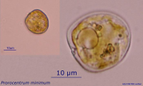

Source: http://nordicmicroalgae.org/taxon/Prorocentrum%20minimum?media\_id=Prorocentrum%20minimum\_8.jpg

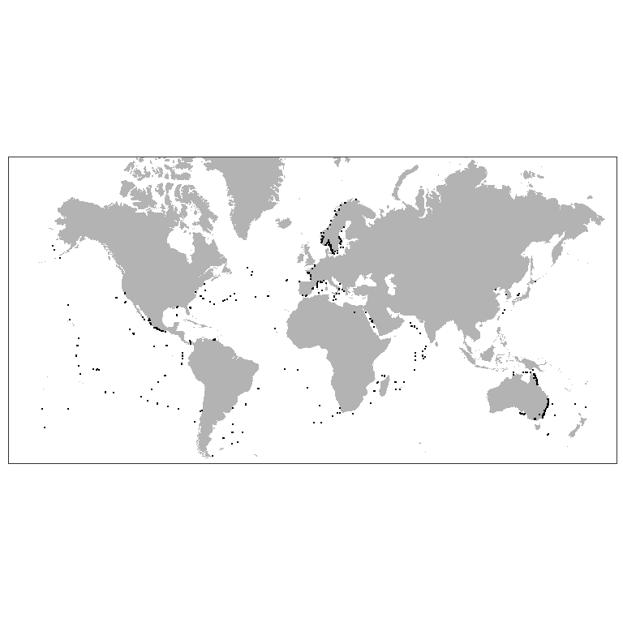

Figure **3.7:** Worldwide distribution of *Prorocentrum cordatum* accordingly to GBIF. Prepared by Consultant

*P. cordatum* (minimum) (Dinophyceae) was introduced in the Baltic Sea and caused recognizable environmental effect (Olenina et al., 2010)[[64]](#footnote-72). This species has wide salinity and temperature tolerance and low-light adaptation (Tyler, Seliger, 1981, Hajdu et al., 2005)[[65]](#footnote-73) [[66]](#footnote-74). *P. minimum* was found also in the White Sea (Ilyash et al., 2018)[[67]](#footnote-75). which proves it to be eurybiotic species. Is one of the red-tide-forming toxic species (Heil et al., 2005)[[68]](#footnote-76). Being introduced into Ob Estuary *P. cordatum* may cause poisoning of the local aquatic organisms, especially in case of intensive warming. Besides that, may occupy spatial niches of native planktonic algae. May be introduced with ballast water.

##### *Acanthocyclops robustus (Sars G.O., 1863)*

**Phyllum:**Arthropoda  
**Class:**Hexanauplia  
**Order:**Cyclopoida  
**Family:** Cyclopidae

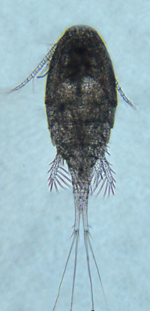

Source: https://www.glsc.usgs.gov/greatlakescopepods/Detail.php?GROUP=Cyclopoid&SPECIES=Acanthocyclops%20robustus

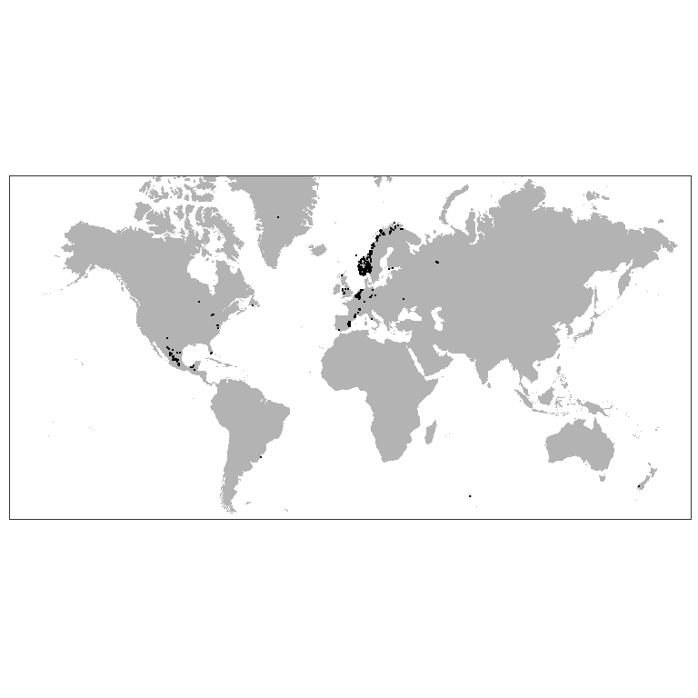

Figure 3.8: Worldwide distribution of *Acanthocyclops robustus* accordingly to GBIF. Prepared by Consultant

*A. robustus* is temperate freshwater species, which is numerous in European lakes, ponds and estuaries (Purasjoki, Viljamaa, 1984; Gonçalves et al., 2012)[[69]](#footnote-77) [[70]](#footnote-78). This species dominates in the freshwater zone of Schelde estuary (Belgium, Netherlands), which is strongly influenced by human activity and characterized by a high load of organic matter as well as toxic substances (Tackx et al., 2004)[[71]](#footnote-79). This species was found to be little affected by environmental gradients, so it must be capable to establish in areas with high variability of environmental parameters, which is typical for Ob Estuary. *A. robustus* was also regularly documented near Helsinki, in area, highly affected by human activity (Purasjoki, Viljamaa, 1984). *A. robustus* was documented in waters along Norwegian coast up to Kola peninsula (Fig. 3.8). This predator, being established, could affect local ecosystem, feeding on local organisms, which do not have behavioral adaptations to this new species. In a perspective, this invasion can lead to significant decrease of populations of prey organisms (Rotifera and small Diplostraca). May be introduced with ballast water.

##### 

##### *Acartia bifilosa (Giesbrecht, 1881)*

**Phyllum:**Arthropoda  
**Class:**Hexanauplia  
**Order:**Calanoida  
**Family:** Acartiidae

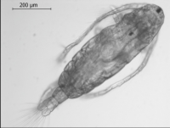

Source:https://www.theseus.fi/bitstream/handle/10024/111318/ect%20of%20Changing%20Environmental%20Conditions%20on%20the%20Reproduction%20Success%20of%20Copepod%20Acartia%20bifilosa.pdf?sequence=1&isAllowed=y

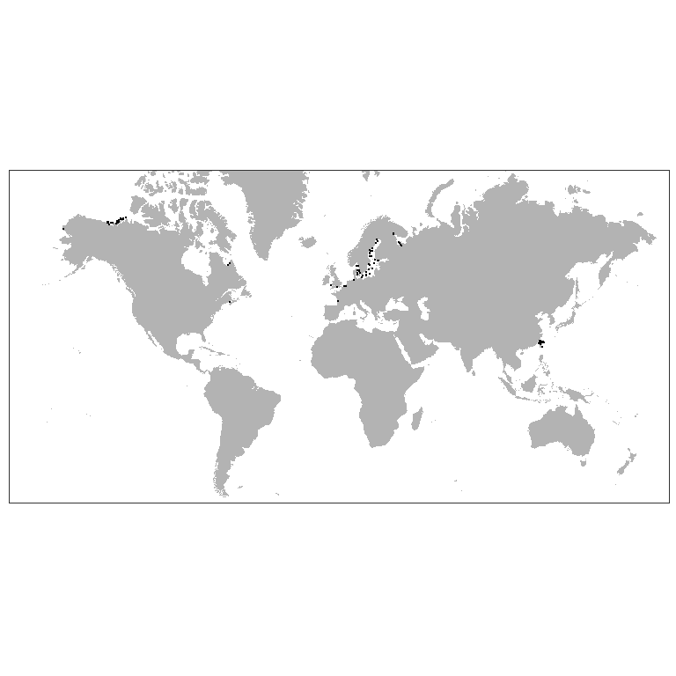

Figure 3.9: Worldwide distribution of *Acartia bifilosa* accordingly to GBIF. Prepared by Consultant

*A. bifilosa* is eryhaline species inhabiting estuaries in the Western Europe (Belgiun, Netherlands), is constituent of brakish-water-marine group in winter-spring (Sautour, Castel, 1995)[[72]](#footnote-80). May survive salinities down to 6-12 psu and temperatures down to 0°C. Was found in estuaries of the northern Europe. *A. bifilosa* is normal component of the summer planktonic community in the White Sea, prefers waters with low salinities in estuaries (Prudkovsky, 2003)[[73]](#footnote-81). *A. bifilosa* lays resting eggs to survive unfavourable conditions. The latter fact may facilitate transfer of this species in ballast waters. *A. bifilosa* is basically herbivorous species, which is capable to feed on animal preys, when phytoplankton is scarce (Martynova et al., 2011)[[74]](#footnote-82). This may lead to competitive pressure of this species on local herbivorous organisms, and negative changes in populations of the latter. May be introduced with ballast water.

##### *Amphibalanus improvisus (Darwin, 1854)*

**Phyllum:**Arthropoda  
**Class:**Thecostraca  
**Order:**Balanomorpha  
**Family:** Balanidae

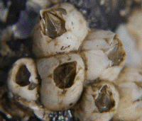

Source:<http://www.sevin.ru/top100worst/priortargets/Arthropods/improvisus.gif>

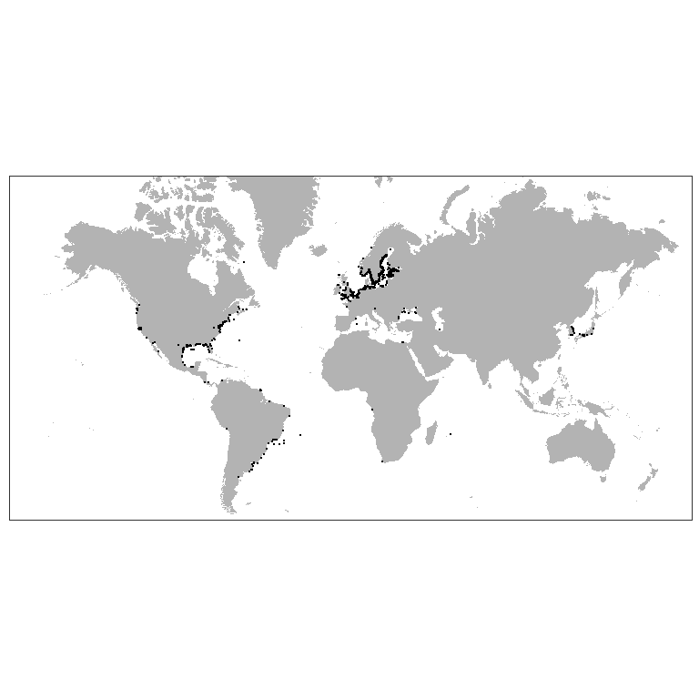

Figure 3.10: Worldwide distribution of *Amphibalanus improvisus* accordingly to GBIF. Prepared by Consultant

These sessile crustaceans have planktonic larvae, so the most likely way of their invasion into the Ob Estuary is the introduction with ballast water. The second route of entry is also possible: on the bottoms of ships. Adult barnacles attached to the hulls of boats would not be able to inhabit the area. However, after cross copulation (they are hermaphroditic animals) the fertilized eggs accumulate in a special cavity where eggs develop and nauplius larvae hatched (Dorit et al. 1991)[[75]](#footnote-83). Then the already formed larvae enter the water column and, after a certain period of swimming, settle on solid substrates and undergo metamorphosis. If vessels with adults of this species regularly enter the Ob estuary, a successful emergence of the nauplii may take place if the temperature is high enough and the salinity is at least 2 ppm (Dineen, Hines, 1992)[[76]](#footnote-84).

In the case of successful colonization, barnacles inhabiting hard substrates (including man-made ones) will increase the structure complexity of the bottom. In the space between the calcareous barnacle’s shells other benthic forms will be able to settle. In case of mass settlement, which is unlikely, there may be failures in underwater structures: increase in friction, decrease in pipelines capacity.

##### *Gammarus tigrinus Sexton, 1939*

**Phyllum:**Arthropoda  
**Class:**Malacostraca  
**Order:**Amphipoda  
**Family:** Gammaridae

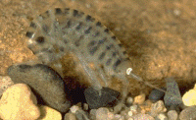

Source:<http://www.sevin.ru/top100worst/priortargets/Arthropods/tigrinus.gif>

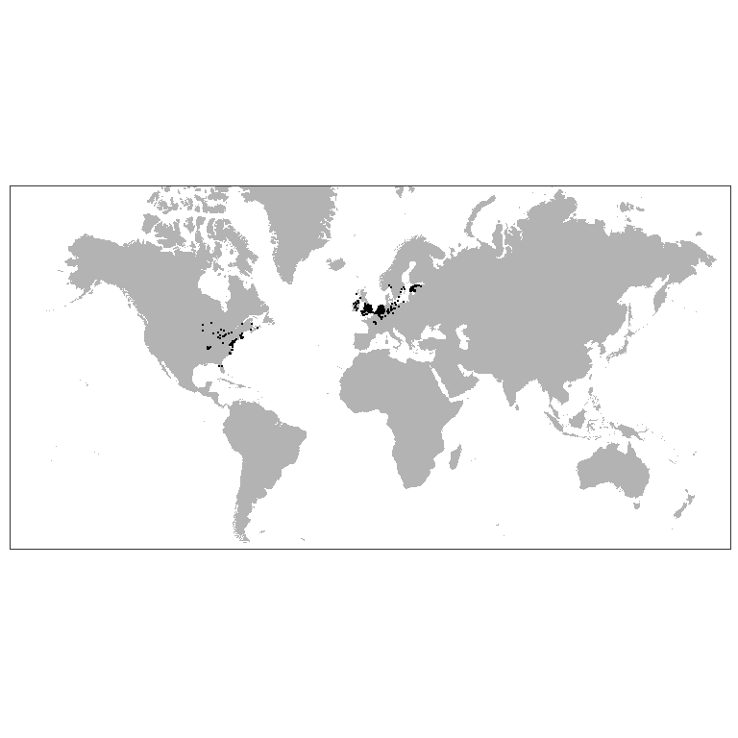

Figure 3.11: Worldwide distribution of *Gammarus tigrinus* accordingly to GBIF. Prepared by Consultant

The most likely vector of introduction of this species is ballast water (Berezina, 2007)[[77]](#footnote-85). The critical factor limiting the normal development of this euryhaline amphipod is temperature. This species can enter reproduction as early as 2 degrees, but developmental duration is delayed at low temperatures (Chambers, 1976)[[78]](#footnote-86).

If introduced successfully, this species could significantly alter the ecosystem structure of the Ob Estuary. The expected impact may be due to the fact that this species is polyphagous and can feed not only on detritus, but also on animals including oligochaetes (Most dangerous invasive species …, 2018)[[79]](#footnote-87), which dominate the benthic communities in the south part of the estuary. The second expected impact may be related to the competitive relationship of the invasive species with native amphipods, primarily *Monoporeia affinis*. The latter species, being one of the most abundant forms of benthos (Integrated investigations… 2020), serve as the basis of diet of valuable fish species inhabiting the Ob Estuary (Stepanova 2017).[[80]](#footnote-88)

It should be noted that an in-depth taxonomic survey of the gammarid fauna in the Ob estuary has not been conducted. Therefore, there is a possibility that this species is already represented in the water area.

##### *Rhithropanopeus harrisii (Gould, 1841)*

**Phyllum:**Arthropoda  
**Class:**Malacostraca  
**Order:**Decapoda  
**Family:** Panopeidae

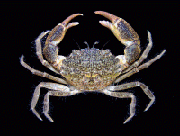

Source:<http://www.sevin.ru/top100worst/priortargets/Arthropods/harrisii.gif>

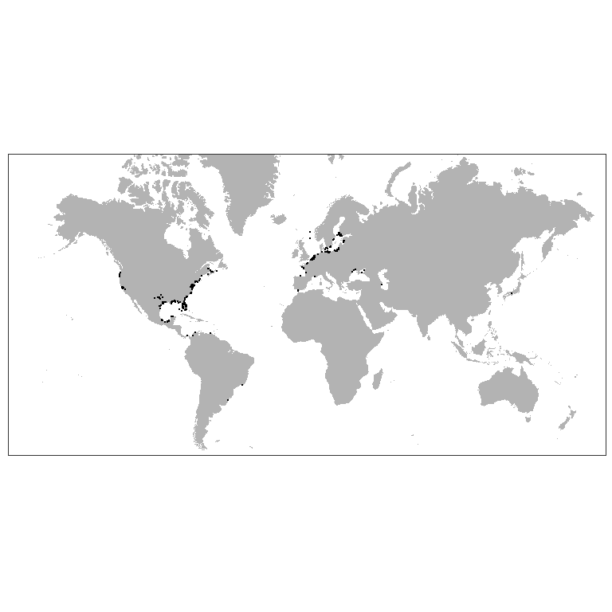

Figure 3.12: Worldwide distribution of *Rhithropanopeus harrisii* accordingly to GBIF. Prepared by Consultant

The main expected vector of transport is ballast water. However, since the crab is very small in size, its infestation is also possible due to ship bottom fouling (Most dangerous invasive species…, 2018 ). The presence of this species in *Dreissena polymorpha* druses seems most likely.

The crab is omnivorous (Most dangerous invasive species …, 2018), which determines its potential threat to native benthos species.

##### *Eriocheir sinensis H. Milne Edwards, 1853*

**Phyllum:**Arthropoda  
**Class:**Malacostraca  
**Order:**Decapoda  
**Family:** Varunidae

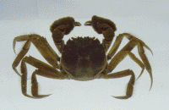

Source: <http://www.sevin.ru/top100worst/priortargets/Arthropods/sinensis.gif>

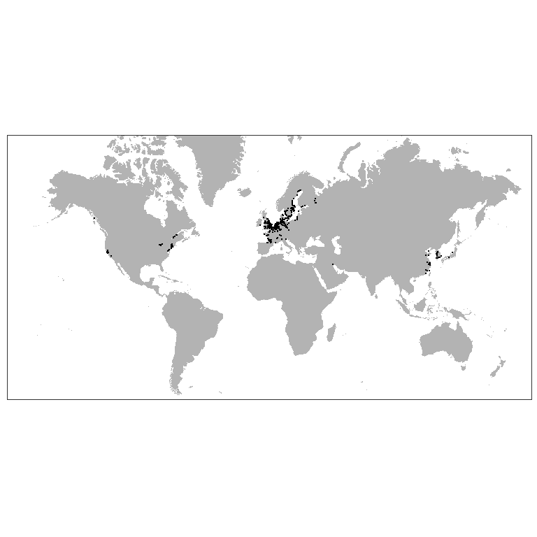

Figure 3.13: Worldwide distribution of *Eriocheir sinensis* accordingly to GBIF. Prepared by Consultant

It is one of the most successful invasive species moving northward (Most dangerous invasive species…, 2018). At present, this species was undoubtly occurred in the estuaries of the White Sea (Berger and Naumov, 2002)[[81]](#footnote-89).

The species belongs to cathodromic organisms, i.e. it migrates from the sea to fresh waters and backward (Most dangerous invasive species…, 2018). Therefore, potentially, with time, it can reach the Ob estuary by natural way. It is also possible to disperse with ballast water (due to pelagic larvae) and as part of ship bottom fouling (The most dangerous invasive species…, 2018).

The species is very tolerant to low temperature (The most dangerous invasive species …, 2018) thus its occurrence in the Ob estuary is very probable.

When introduced, this species, being a polyphagous, can significantly impact on both benthic invertebrates and on fish, eating their eggs (Most dangerous invasive species …, 2018). Another potential impact could be digging of burrowes that can reach several tens of centimeters (Most Dangerous Invasive Species …, 2018), this can destabilize bottom sediment .

##### *Dreissena polymorpha (Pallas, 1771)*

**Phyllum:**Mollusca  
**Class:**Bivalvia  
**Order:**Myida  
**Family:** Dreissenidae

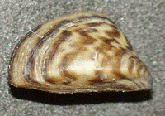

Source: http:[//www.sevin.ru/top100worst/priortargets/Mollusca/polymorpha.gif](http://www.sevin.ru/top100worst/priortargets/Mollusca/polymorpha.gif)

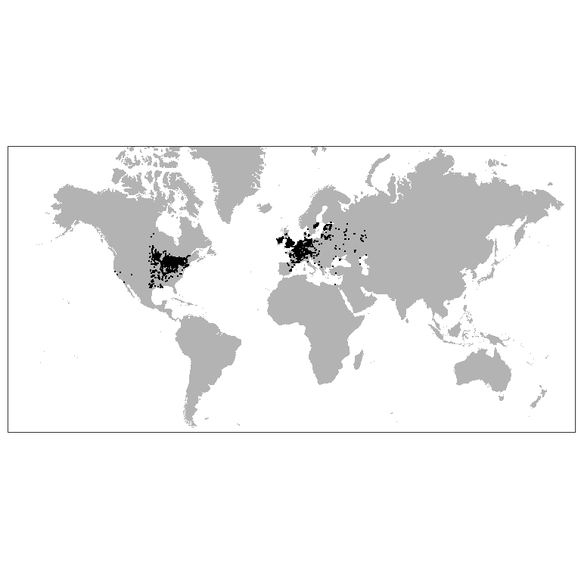

Figure 3.14: Worldwide distribution of *Dreissena polymorpha* accordingly to GBIF. Prepared by Consultant

This is a typical fouling species settling on hard underwater substrates (Orlova, 2002)[[82]](#footnote-90). Adults are likely to be introduced on ship’s bottoms (Orlova, 2002). In the case of detachment of adult mollusks from the ship’s bottoms, they can re-establish themselves on natural and anthropogenic substrates of ship mooring areas. The important condition for this scenario could be realized is that a vessels should stay for quite a long time in water areas where dense settlements of this species are present, which will provide a sufficiently large number of larvae competent for settling. Such locations include many ports in Europe. However, ballast water, which may contain very small planktonic larvae of this species, seems to be the most likely route of introduction of this species (Orlova, 2002; Karatayev, 2007) [[83]](#footnote-91). These clams actively spread in the northern direction: settlements of this clam in the rivers of the Northern Dvina basin are reliably known (Makhnovich, 2018; Travina et al. 2020)[[84]](#footnote-92) [[85]](#footnote-93) .

In the case of successful colonization, clams will be able to form settlements on natural hard substrates and hydro-technical constructions. The most likely places of settlement formation are pipelines associated with heated water. This can lead to reduced efficiency or equipment failure.

The impact of these mollusks on the ecosystem is ambiguous (Karatayev, 2007). On the one hand, by increasing the structure complexity of the biotope, additional microbiotopes for native species (oligochaetes, crustaceans) may appear. On the other hand, filter mollusks may lead to a decrease in the abundance of phytoplankton. It is important that settlements of this species may lead to changes in the content of biogens in water (Karatayev, 2007), which may significantly increase the phytobenthos development.

If the invasion of this species occurs, it seems expectedly to spread upstream of the Ob River, where, most likely, dense settlements will be formed.

##### *Mya arenaria Linnaeus, 1758*

**Phyllum:**Mollusca  
**Class:**Bivalvia  
**Order:**Myida  
**Family:**Myidae  
`

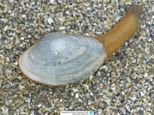

Source:<https://www.meerwasser-lexikon.de/imgHaupt/52049_58ddf591ae3e0.jpg>

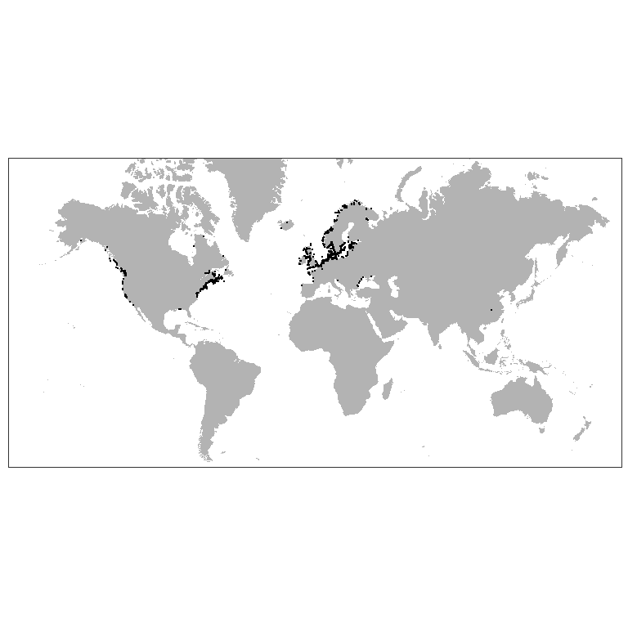

**Figure 3.15: Worldwide distribution of Mya arenaria accordingly to GBIF. Prepared by Consultant**

Despite the fact that this species successfully colonizes the cold estuaries of Alaska (Powers et al., 2006)[[86]](#footnote-94), it is more likely to belong to the marine fauna. So its invasion, if it occurs, will expectedly be associated with deep-water areas where more dense sea water enters.

This burrowing in muddy sediments bivalve feeds on suspended benthic organic particles. In the White Sea, where temperature conditions are close to the Arctic seas, this species may show high abundance (Gerasimova et al., 2021)[[87]](#footnote-95). In the Black Sea, where this species has recently introduced, the formation of dense aggregations of this species has led to some changes in sedimentation patterns (Zolotarev, 1996)[[88]](#footnote-96). Through burrowing activity, these molluscs may contribute to sediment aeration and slow the formation of hydrogen sulfide in bottom sediments (Hansen et al., 1996)[[89]](#footnote-97), positively affecting the infauna. Therefore, there is no reason to predict a significant negative impact of this species on the Ob Estuary ecosystem.

##### *Potamopyrgus antipodarum (Gray, 1843)*

**Phyllum:**Mollusca  
**Class:**Gastropoda   
**Order:**Littorinimorpha   
**Family:** Tateidae

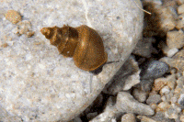

Source: <http://www.sevin.ru/top100worst/priortargets/Mollusca/antipodarum.gif>

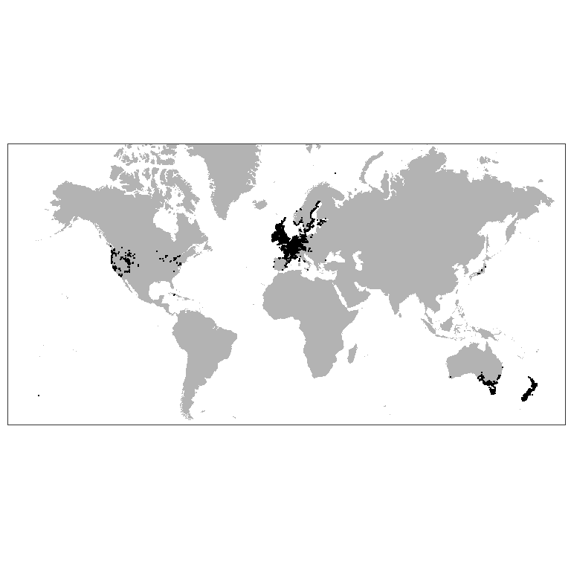

**Figure 3.16: Worldwide distribution of Potamopyrgus antipodarum accordingly to GBIF. Prepared by Consultant**

The most probable way of introduction of this species is with ballast water. However, due to the fact that this species well tolerates passage through the digestive tract of birds (The most dangerous invasive species…, 2018), natural introduction of this species is also possible. However, in the development of this scenario, the spread of the species will take place, rather, from the upper Ob-Yenisei system. In the case of formation of *Dreissena polymorpha* populations in the Ob estuary, it will be able to actively colonize this biotope (The most dangerous invasive species…, 2018). There is no reliable basis for predicting the consequences (both negative and positive) of the invasion of this species.

##### *Marenzelleria Mesnil, 1896*

**Phyllum:**Annelida  
**Class:**Polychaeta  
**Order:**Spionida  
**Family:** Spionidae

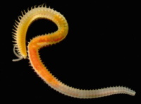

Source:<https://www.researchgate.net/profile/Erik-Bonsdorff/publication/315868278/figure/fig3/AS:555115704979458@1509361305933/Marenzelleria-is-an-example-of-a-highly-successful-non-indigenous-polychaete-genus-in-the_W640.jpg>

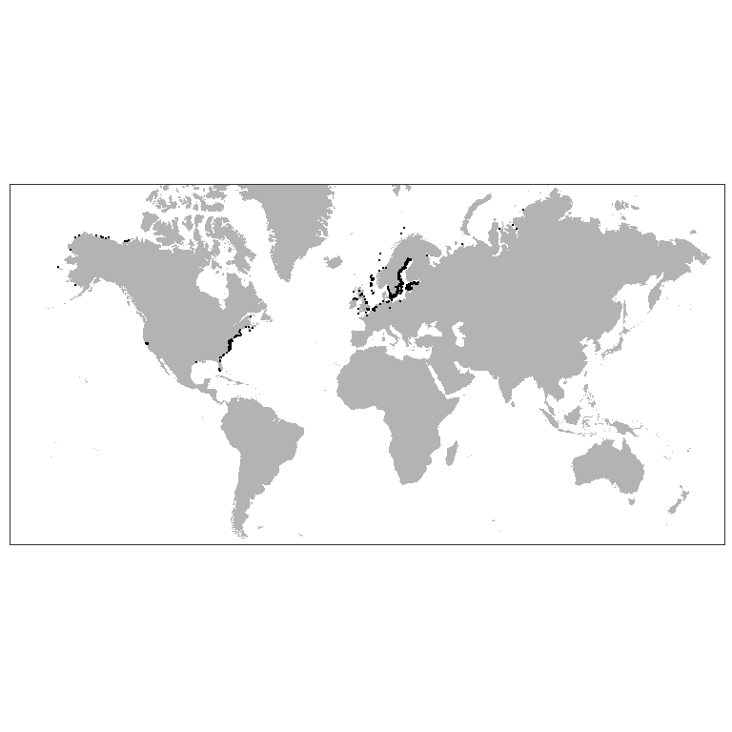

**Figure 3.17: Worldwide distribution of Marenzelleria accordingly to GBIF. Prepared by Consultant**

De-facto worms of this genus already occur and are very abundant in the Ob Estuary (Integrated investigations… 2020). However, without a detailed genetic analysis, only one species, *M.wireni*, noted in previous studies (Galkin et al. 2010),[[90]](#footnote-98) cannot be confidently asserted to be represented in the Obi Estuary.

These polychaetes were not noted in early studies of the zoobenthos of the Ob Estuary (Stepanova et al. 2011).[[91]](#footnote-99) However, worms of this genus were already encountered in 1993 (Galkin et al. 2010) and were among the guiding forms, but only at one station located much more northward than stations where these forms were abundant in later surveys (Integrated investigations… 2020, Final report…, 2021). These data indirectly indicate an expansion of the area populated by this species and an increase in its abundance in the area. Considering that species of the genus *Marenzelleria* show active invasion in the Baltic and North Sea (Kauppi et al., 2015), we can assume that the presence of these polychaetes in the Ob Estuary is the result of relatively recent colonization. The presence of *Marenzelleria* may lead to a marked stimulation of sulfate reduction and degradation of organic matter (Quintana et al., 2013)[[92]](#footnote-100).

### Alien Fish Species

E.A. Interesova (2018)[[93]](#footnote-101) reported the presence of 22 alien fish species in the Ob basin. Since 1970s, representatives of ichthyofauna from the southern waterbodies, such as bream (*Abramis brama*), pike perch (*Sander lucioperca*), and carp (*Cyprinus carpio*) have been observed in the Ob Estuary. Originally, these fish got to the Ob River from the Novosibirsk water reservoir where they were introduced, and then migrated to the Ob Estuary under the effect of suffocative water. Bream became common in the Mid-Ob Region where it reproduces successfully; however, no facts of its reproduction in the Ob Estuary have been registered. Bream comes to the Estuary from the Ob River as suffocative water forces it out in winter period. The number of breams in the Ob Estuary can be quite significant, but living conditions there are not favourable for this species due to cold water, and the population has to continuously recruit new individuals. In 2018, two specimens of bream were caught in Venuimuyeyakha River in the course of biodiversity monitoring of the South Tambey LA (Biodiversity monitoring ..., 2018)[[94]](#footnote-102) (Figure 3.18).

Also, since the 70s of the XX century, pink salmon (*Oncorhynchus gorbuscha*) has been found in the Gulf of Ob, which fell into the Kara Sea after its introduction in the White Sea. This species is regularly found in small quantities in the Ob Bay and the mouths of rivers flowing into it during the open water period only in even years[[95]](#footnote-103). In particular, in 2017, pink salmon in the water area of the Gulf of Ob was noted during engineering and environmental surveys. In September 2021 this species was caught in the Khaltsyney-Yakha mouth (Figure 3.19)). It is noted that the specimens caught in the Ob Bay most likely belong to self-reproducing groups of Norway and the Kola Peninsula, and the naturalization of pink salmon in the Project area is unlikely due to the duration of the subglacial period of more than 240 days, the freezing of rivers suitable for spawning this species to the bottom and the formation of local fish kills, which prevents the development of caviar and larvae.

|  |  |
| --- | --- |
| Снимок экрана от 2022-01-27 19-02-53 |  |
| **Figure 3.18: Bream (Abramis brama) in the Venuime-Yakha river in 2018 (FRECOM, 2018)** | **Figure 3.19: Pink salmon (Oncorhynchus gorbuscha) in the Khaltsyney-Yakha mouth in September 2021 (IEPI, 2021)** |

Local fish species that may be exposed to the harmful effects of humpback salmon spawning activity (characterized by grubbing of bottom soil for the nest) reportedly include Arctic cisco, however, there is no evidence of competitive relations of cisco and humpback salmon, due to the low numbers of populations of both species (Bogdanov, Kizhevatov, 2015)[[96]](#footnote-104).

Both alien fish species living in the northern part of the Ob Estuary have a low abundance and so far most likely do not affect the native ichthyofauna. It is unlikely that Project activities will contribute to the spread of these species. The planned release of fish to compensate for damage to aquatic biological resources does not involve the introduction of alien species and includes native muksun and Siberian Sturgeon.

## Terrestrial Realms

### Alien Plants in the Yamal-Gydan sector of the Arctic

The Arctic is one of only a few areas or the world where ecosystems remain minimally affected by non-native species (Lassuy, Lewis, 2013[[97]](#footnote-105); Morozova, Tishkov, 2021[[98]](#footnote-106)). However, climate change (IPCC 2018[[99]](#footnote-107)) and increasing industrial activities are particularly acute in the Arctic, possibly diminishing many of the constraints to the importation and establishment of non-native plant (Wasowicz et al., 2020). By modern estimate the presence of 341 non-native taxa in the Arctic (according to CAFF) was confirmed, of which 188 are naturalized in at least one of the regions (Wasowicz et al., 2020). In the Russian Arctic, (area according to Sekretareva, 2004[[100]](#footnote-108)) 333 alien plant species were recorded. Showed that the introduction and spread of alien species in the Russian Arctic is currently locally and mostly associated with settlements, industrial centers and transport routes. In recent years, a preliminary assessment of non-native flora of the YNAO has been carried out, which includes both the tundra and the boreal zones: 216 vascular non-native plant species have been reported[[101]](#footnote-109).

A special study of alien species has not previously been carried out for the Yamal-Gydan sector of the Arctic. In a review for the Arctic regions, P. Wasowicz et al. (2020) lists 29 non-native species. Based on compilation of literature sources, reports and herbarium specimen, we were able to identify 53 non-native species of vascular plants for the territory (Table 3.3). Main part of records were confined in the territory of roads and populated places: Bovanenkovo, Yamburg, Novyi Port, Sabetta, and Utrenniy.

Table 3.3: Check-list of non-native vascular plants in the Yamal-Gydan sector of the Arctic (Prepared by Consultant).

| No. | Species | Source of first record | Pathway category |
| --- | --- | --- | --- |
|  | *Alopecurus geniculatus* L. | FRECOM, 2018 | Transport–Stowaway (4) |
|  | *Arctium tomentosum* Mill. | Byalt, Egorov, 2019 | Transport–Stowaway (4) |
|  | *Artemisia vulgaris* L. | Byalt, Egorov, 2019 | Transport–Contaminant (3) |
|  | *Atriplex prostrata* DC. | MW herbarium | Transport–Contaminant (3) |
|  | *Avena sativa* L. | IEPI, 2021 | Transport–Contaminant (3) / Release in nature (1) |
|  | *Barbarea vulgaris* W.T. Aiton | Byalt, Egorov, 2019 | Transport–Contaminant (3) |
|  | *Beckmannia eruciformis* (L.) Host | MW herbarium | Release in nature (1) |
|  | *Brassica napus* L. | IEPI, 2021 | Transport–Contaminant (3) |
|  | *Bromus inermis* Leyss. | MW herbarium | Release in nature (1) |
|  | *Campanula glomerata* L. | Yurtsev, 1987 | unknown |
|  | *Capsella bursa-pastoris* (L.) Medikus | IEPI, 2021 | Transport–Contaminant (3) |
|  | *Cerastium fontanum* subsp. *vulgare* (Hartman) Greuter & Burdet | Byalt, Egorov, 2019 | Transport–Contaminant (3) |
|  | *Chenopodium album* L. | Byalt, Egorov, 2019 | Transport–Contaminant (3) |
|  | *Cichorium intybus* L. | Byalt, Egorov, 2019 | Transport–Contaminant (3) |
|  | *Dactylis glomerata* L. | Byalt, Egorov, 2019 | Transport–Contaminant (3) |
|  | *Descurainia sophia* (L.) Webb ex Prantl | Pismarkina, Bystrushkin, 2019 | Transport–Contaminant (3) |
|  | *Draba nemorosa* L. | Tolmachev, 1975 | Transport–Stowaway (4) |
|  | *Elymus repens* (L.) Gould | Byalt, Egorov, 2019 | Release in nature (1) / Transport–Stowaway (4) |
|  | *Festuca arundinacea* Schreb. | IEPI, 2021 | Transport–Contaminant (3) |
|  | *Galium spurium* subsp. *vaillantii* (DC.) Gaudin. | Byalt, Egorov, 2019 | Transport–Contaminant (3) |
|  | *Galeopsis* sp. | FRECOM, 2018 | Transport–Contaminant (3) |
|  | *Helianthus annuus* L. | MW herbarium | Transport–Contaminant (3) |
|  | *Juncus bufonius* L. s.l. | Dorogostaiskaya, 1972 | Transport–Stowaway (4) |
|  | *Lathyrus pratensis* L. | Pismarkina, 2014 | Transport–Stowaway (4) |
|  | *Lepidium ruderale* L. | MW herbarium | Transport–Contaminant (3) |
|  | *Lolium perenne* L. | MW herbarium | Release in nature (1) |
|  | *Lolium multiflorum* Lam. | MW herbarium | Transport–Contaminant (3) |
|  | *Melilotus* sp. | IEPI, 2021 | Transport–Contaminant (3) |
|  | *Phacelia tanacetifolia* Benth. | Pismarkina, 2019 | Transport–Contaminant (3) |
|  | *Phleum pratense* L. subsp. *pratense* | Byalt, Egorov, 2019 | Release in nature (1) |
|  | *Plantago major* L. | Byalt, Egorov, 2019 | Transport–Stowaway (4) |
|  | *Poa annua* L. | Kniazev et al., 2006 | Transport–Stowaway (4) |
|  | *Poa compressa* L. | Kniazev, Morozova, 2006 | Transport–Stowaway (4) |
|  | *Rorippa brachycarpa* (C.A. Mey.) Hayek | Kniazev, Morozova, 2006 | Transport–Stowaway (4) |
|  | *Polygonum aviculare* L. | Byalt, Egorov, 2019 | Transport–Contaminant (3) / Transport–Stowaway (4) |
|  | *Potentilla anserina* L. | Pismarkina, 2014 | Transport–Stowaway (4) |
|  | *Potentilla intermedia* L. | Byalt, Egorov, 2019 | Transport–Contaminant (3) |
|  | *Potentilla norvegica* L. | Rebristaya, 2006 | Transport–Contaminant (3) |
|  | *Puccinellia distans* (Jacq.) Parl. | Kniazev et al., 2006 | Transport–Stowaway (4) |
|  | *Rumex acetosella* L. | Byalt, Egorov, 2019 | Transport–Contaminant (3) |
|  | *Rumex longifolius* DC. | Byalt, Egorov, 2019 | Transport–Contaminant (3) |
|  | *Rumex pseudonatronatus* (Borb.) Murb. | Byalt, Egorov, 2019 | Transport–Contaminant (3) |
|  | *Silene latifolia* subsp. *alba* (Miller) Greuter & Burdet | Byalt, Egorov, 2019 | Transport–Contaminant (3) |
|  | *Stellaria media* (L.) Vill. | Rebristaya, 1999 | Transport–Stowaway (4) |
|  | *Taraxacum officinale* Wigg. s.l. | FRECOM, 2018 | Transport–Stowaway (4) |
|  | *Tanacetum vulgare* L. | Yurtsev, 1987 | Transport–Stowaway (4) |
|  | *Thlaspi arvense* L. | IEPI, 2021 | Transport–Contaminant (3) |
|  | *Trifolium repens* L. | Pismarkina, 2014 | Transport–Contaminant (3) |
|  | *Trifolium pratense* L. | IEPI, 2021 | Transport–Contaminant (3) / Release in nature (1) |
|  | *Tripleurospermum inodorum* (L.) Sch.-Bip | Byalt, Egorov, 2019 | Transport–Contaminant (3) |
|  | *Triticum aestivum* L. | IEPI, 2021 | Transport–Contaminant (3) |
|  | *Vicia cracca* L. | FRECOM, 2018 | Transport–Contaminant (3) |
|  | *Urtica dioica* subsp. *dioica* L. | Pismarkina, 2014 | Transport–Stowaway (4) |

A retrospective assessment has been showing a distinct increase in the number of alien species on the territory of the for the Yamal-Gydan sector of the Arctic since 1990 (Figure 3.20). It strongly corresponds to the exponential dependence (p<0.05). We associate this with the development of gas fields and related infrastructure. Evidence of the complete absence or low number of alien species can be found in detailed floristic works on the territory until the 1990s (Tvorogov,1988[[102]](#footnote-110); Rebristaya, 2013). The ecological engineering monitoring data by Institute of Ecological Design and Surveys testify to the current actively processes of non-native plant introduction: in the area of the Salmanovsky (Utrenny) license area, there were no non-native species in 2018, but already in 2020, 11 aliens were identified.

Figure 3.20: Numbers of non-native species per periods 1990-2021 in the Yamal-Gydan sector of the Arctic based on literature data and herbarium specimens. Prepared by Consultant

Analysis of the check-list using data on the ecology of the species, information on specific locations and deliberate introduction during restoration works allowed to establish three pathways of the introduction (Table 3.3). They correspond to our assumptions during the analysis of the current situation. At present, the largest number of species on the territory of the Yamal-Gydan sector of the Arctic are listed as contaminants of the seed material of grass mixtures and imported soil by weed species for restoration and compose 57%. 13% of the species were originally introduced as the basis of seed material for restoration, but they spread beyond these areas (Figure 3.21).

Figure 3.21: Percentage of different introduction pathways of non-native species in the Yamal-Gydan sector of the Arctic. Prepared by Consultant

To date, 11 alien species have been identified in Arctic LNG 2 Area of Influence: *Brassica napus*, *Avena sativa,* *Melilotus* sp., *Tripleurospermum inodorum*, *Chenopodium album*, *Thlaspi arvense*, *Triticum aestivum,* *Festuca arundinacea,* *Melandrium album,* *Trifolium pratense, Rumex longifolius* All these species entered the territory to as contaminants of grass mixtures. We don’t have any data on degree of naturalization and speed of spread in areas.

### The Most Expected Invasive Plants

The currently available information on the flora of the Yamal-Gydan sector of the Arctic is characterized by low completeness. Data on record locations, abundance, state of populations, flowering and fruiting of species are given in single publications. In this regard, we are not able to characterize the degree of naturalization of each species within this territory at the present time. We provide a small essays for six potentially invasive species and forecast of their distribution within the Yamal-Gydan sector of the Arctic:

Wild chervil(*Anthriscus sylvestris* (L.) Hoffm. subsp. *sylvestris*)

Life form: herbaceous short-lived perennial plant with root sprouts.

Native distribution: temperate zone of Europe, western Asia, northern Africa and Far East.

Secondary distribution in the Arctic: Western Greenland, North Iceland, Svalbard, Kanin-Pechora, Taimyr-Severnaya Zemlya.

Secondary distribution in the Yamal-Gydan sector: No data.

Pathway of introduction: No data.

Invasion status: No data.

Forecast of the invasive process: The presence of *Anthriscus sylvestris* in the territory of the Yamal-Gydan sector is very likely, since this species is massively dispersed in various territories of the northern regions (Dorogostaiskaya, 1972). It primarily occupies disturbed habitats within the territories of existing and abandoned settlements, from which it invades to natural meadows along rivers and marine coastal communities. *Anthriscus sylvestris* can exist for a long time in the Arctic, e.g. it has been recorded in Svalbard more than 30 years, where it is potentially invasive as it has produced mature fruits (Alsos et al., 2015)[[103]](#footnote-111). In Iceland, this species has the status of an invasive species (Wasowicz,2013[[104]](#footnote-112)).

In the YNAO, the species occurs naturally within the taiga zone, where it is represented by the subspecies *Anthriscus sylvestris* subsp. *aemula* (Woronow) Soó. The type subspecies should occur only in disturbed habitats.

|  |  |
| --- | --- |
| C:\Users\Mikhail Kozhin\AppData\Local\Microsoft\Windows\Temporary Internet Files\Content.Word\IMG_1065.jpg | C:\Users\Mikhail Kozhin\AppData\Local\Microsoft\Windows\Temporary Internet Files\Content.Word\Anthriscus sylvestris_ill.tif |

Figure 3.22: General view (photo by M. Kozhin) and habitat suitability model of *Anthriscus sylvestris* (L.) Hoffm. subsp. *sylvestris* (prepared by Consultant)

Smooth brome (*Bromus inermis* Leyss.)

Life form: herbaceous perennial plant with creeping rhizomes.

Native distribution: temperate zone of Europe and Asia Caucasus, Middle Asia, Mongolia.

Secondary distribution in the Arctic: South and East Chukotka, North and West Alaska, Western Greenland, North Iceland, North Fennoscandia, Yamal-Gydan, Taimyr-Severnaya Zemlya.

Secondary distribution in the Yamal-Gydan sector: roads embankments in the vicinity of Bovanenkovo Settlement, Yamburg Settlement.

Pathway of introduction: Release in nature. It was used earlier and is used now for restoration. It is one of the most commonly used components of grass mixtures.

Invasion status: naturalized (established) plants.

Forecast of the invasive process: Potentially *Bromus inermis* is one of the most dangerous invasive species. It has been tested many times in grass sowing in the Far North in Eurasia and America (Dorogostaiskaya, 1972). *Bromus inermis* is currently one of the most aggressive invasive species rapidly spreading in Alaska (Fink, Wilson, 2011)[[105]](#footnote-113). Negative impact of *Bromus inermis* invasion was caused by increased resource demand and decreased availability of light and water[[106]](#footnote-114). Accounted local spreading of the species in the Yamal-Gydan sector of the Arctic, we predict its active expansion in disturbed and natural meadow habitats. In the more southern area, mainland part of the YNAO, the species is relatively common (Tolmachev, 1964; Dorogostaiskaya, 1972; Vilchek, Kuznetsov, 1996[[107]](#footnote-115); Knyazev et al., 2006; etc.) and continues to settle, occupying more and more northern territories (Pismarkina, Byalt, 2016)[[108]](#footnote-116).

|  |  |
| --- | --- |
| C:\Users\Mikhail Kozhin\AppData\Local\Microsoft\Windows\Temporary Internet Files\Content.Word\IMG20200708182255.jpg | C:\Users\Mikhail Kozhin\AppData\Local\Microsoft\Windows\Temporary Internet Files\Content.Word\Bromus inermis_ill.tif |

Figure 3.23: General view (photo by M. Kozhin) and habitat suitability model of *Bromus inermis* Leyss. (prepared by Consultant)

Couch grass (*Elymus repens* (L.) Gould)

Life form: herbaceous perennial plant with creeping rhizomes.

Native distribution: temperate zone of Europe and Asia, Caucasus, Western and Middle Asia, Mongolia, northern Africa.

Secondary distribution in the Arctic: South and East Chukotka, North and West Alaska, Western Greenland, North Fennoscandia, Svalbard, Kanin-Pechora, Yamal-Gydan, Taimyr-Severnaya Zemlya.

Secondary distribution in the Yamal-Gydan sector: several localities the vicinity of Bovanenkovo and Yamburg Settlements.

Pathway of introduction: Release in nature. It was used earlier and is used now for restoration. It is one of the most commonly used components of grass mixtures.

Invasion status: naturalized (established) plants.

Forecast of the invasive process: On the territory of the Yamal-Gydan sector of the Arctic it is still known from single localities. In the continental part of the YaNAO *Elymus repens* is a fairly widespread species usually confined to the territories of settlements and disturbed areas (Dorogostaiskaya, 1972; Vilchek, Kuznetsov, 1996; Knyazev et al., 2006; Pismarkina, Byalt, 2016). In various regions of the Far North, it is one of the most common alien plants (Dorogostaiskaya, 1972, Wasowicz et al., 2020). Due to special biological characteristics *Elymus repens* has active vegetative reproduction and is able to form seeds in the most favorable years (Shlyakova, 1982)[[109]](#footnote-117). For example, samples collected in August in Yamburg already contained ripening seeds. We assume that *Elymus repens* will actively disperse in disturbed habitats of the developed areas of the territory and possibly introduces into the natural communities of riverine and coastal meadows. The Department of Natural Resource Regulation and Forest Relations of the YaNAO draws attention to this problem at seminars for subsoil users meanwhile any approach to control spread has not yet been proposed.

|  |  |
| --- | --- |
| C:\Users\Mikhail Kozhin\AppData\Local\Microsoft\Windows\Temporary Internet Files\Content.Word\elytrigia.jpg | C:\Users\Mikhail Kozhin\AppData\Local\Microsoft\Windows\Temporary Internet Files\Content.Word\Elymus repens_ill.tif |

Figure 3.24: General view (photo by L. Palamarchuk by plantarium.ru) and habitat suitability model of *Elymus repens* (L.) Gould. (prepared by Consultant)

Chickweed (*Stellaria media* (L.) Vill.)

Life form: herbaceous annual plant with taproot.

Native distribution: Europe.

Secondary distribution in the Arctic: West, South and East Chukotka, North Alaska - Yukon Territory, Western Alaska, Svalbard, Kanin-Pechora, Polar Ural-Novaya Zemlya, Yamal-Gydan, Taimyr-Severnaya Zemlya, Kharaulakh.

Secondary distribution in the Yamal-Gydan sector: abandoned place in Novyi Port Village and in the vicinity of Syunaisale Village.

Pathway of introduction: Transport–Stowaway (4) with transporting vessels and associated equipment.

Invasion status: naturalized (established) plants.

Forecast of the invasive process: On the territory of the Yamal-Gydan sector of the Arctic it is still known from single localities. In the continental part of the YaNAO is a common weed in populated places (Dorogostaiskaya, 1972; Pismarkina, 2014 Pismarkina et al, 2020). In the tundra zone in various sectors of the Arctic, it is often found in the territory of populated places and arable fields (Dorogostaiskaya, 1972; Shlyakova, 1982). The plant has a very high seed productivity: till 8,000–25,000 seeds. Immature seeds with a green surface are able to form flowering and fruiting plants. Seeds are able to germinate at low temperatures even under a thin layer of snow. Seeds are able to remain viable after passing through the intestines (Shlyakova, 1982). The biological features and the modern active development of the territory, will probably become a necessary driver for a wider distribution of the species on the the Yamal-Gydan sector of the Arctic. We predict its distribution in human-disturbed habitats and in nature including bird colonies, floodplain communities and coastal meadows.

|  |  |
| --- | --- |
| C:\Users\Mikhail Kozhin\AppData\Local\Microsoft\Windows\Temporary Internet Files\Content.Word\Stellaria.jpg | C:\Users\Mikhail Kozhin\AppData\Local\Microsoft\Windows\Temporary Internet Files\Content.Word\Stellaria media_ill.tif |

Figure 3.25: General view (photo by S. Dudov) and habitat suitability model of *Stellaria media* (L.) Vill. (prepared by Consultant)

White clover (*Trifolium repens* L.)

Life form: herbaceous perennial plant with creeping rhizomes.

Native distribution: temperate zone of Europe and Asia, Caucasus, Western and Middle Asia, Mongolia, northern Africa.

Secondary distribution in the Arctic: West Chukotka, Western Alaska, Western Greenland, Svalbard, Kanin-Pechora, Polar Ural-Novaya Zemlya, Yamal-Gydan, Taimyr-Severnaya Zemlya, Kharaulakh, Yana-Kolyma.

Secondary distribution in the Yamal-Gydan sector: abandoned place in Novyi Port Village.

Pathway of introduction: Transport–Stowaway (4) with transporting vessels and associated equipment.

Invasion status: casual alien plants.

Forecast of the invasive process: On the territory of the Yamal-Gydan sector of the Arctic it is still known from a single location. In the mainland of the YaNAO it is a common plant in all large settlements (Pismarkina et al., 2019)[[110]](#footnote-118), and also found in disturbed habitats outside of they (Pismarkina, Byalt, 2016). Relatively common in disturbed habitats and arable fields in the Arctic (Dorogostaiskaya, 1972). The plant can actively spread by creeping rooted rhizomes (Shlyakova, 1982) and has nitrogen-fixing properties, making it a transformative species within ecosystems (Scherer-Lorenzen et al., 2008)[[111]](#footnote-119).). We predict its active further dispersal in disturbed habitats in places of settlements and construction work, and we also do not exclude its invasion into natural habitats, such as river and coastal meadows.

|  |  |
| --- | --- |
| F:\Фото Камчатка\IMGP0207.JPG | C:\Users\Mikhail Kozhin\AppData\Local\Microsoft\Windows\Temporary Internet Files\Content.Word\Trifolium repens_ill.tif |

Figure 3.26: General view (photo by M. Kozhin) and habitat suitability model of *Trifolium repens* L. (prepared by Consultant)

Common nettle (*Urtica dioica* L. subsp. *dioica*)

Life form: herbaceous perennial plant with creeping rhizomes.

Native distribution: temperate zone of Europe and Asia, Caucasus, northern Africa.

Secondary distribution in the Arctic: East Chukotka, Western Greenland, North Iceland, Svalbard, Kanin-Pechora, Polar Ural-Novaya Zemlya, Yamal-Gydan, Taimyr-Severnaya Zemlya, Yana-Kolyma.

Secondary distribution in the Yamal-Gydan sector: abandoned place in Novyi Port Village and roadside embankment in 24 km NW from Bovanenkovo Settlement.

Pathway of introduction: Transport–Stowaway (4) with autotransport and associated equipment.

Invasion status: casual alien plants.

Forecast of the invasive process: Currently only known from two localities in the Yamal-Gydan sector of the Arctic. The species is rarely found in adjacent areas and was known from Salekhard (Tolmachev, 1966), Labytnangi (Trotsenko, 1990[[112]](#footnote-120)), Noyabrsk, Gubkinskii (Pismarkina et al., 2019), Novyi Urengoi and Priozernyi (Pismarkina, Khitun, 2019)[[113]](#footnote-121). In the east of the mainland of YaNAO, it is still rare, probably due to the poor development of horticulture and the lack of nitrogen in local soils (Pismarkina et al., 2019). Generally in the the YaNAA *Urtica dioica* occur often or commonly and characterize to urban landscapes (Pismarkina et al., 2020). We predict further active expansion of this species in disturbed areas and in natural habitats rich in nitrogen, in particular, in places near nesting birds, especially in the territories of their colonies and along river valleys.

|  |  |
| --- | --- |
| C:\Users\Mikhail Kozhin\AppData\Local\Microsoft\Windows\Temporary Internet Files\Content.Word\Urtica.jpeg | C:\Users\Mikhail Kozhin\AppData\Local\Microsoft\Windows\Temporary Internet Files\Content.Word\Urtica dioica_ill.tif |

Figure 3.27: General view (photo by M. Kozhin) and habitat suitability model of *Urtica dioica* L. subsp. *dioica*. (prepared by Consultant)

### Invasive Plants and Climate Change

Arctic ecosystems change rapidly [[114]](#footnote-122)[[115]](#footnote-123) [[116]](#footnote-124). We built species distribution models for six most expected alien species and projected it on three scenario of climate change in 2041-2070 (methods in more detail are discussed in the section 2.2.2). We proceed from the assumption that an increase of the habitat suitability under climate change indicates a risk of invasion for the considered species. Figure 3.28 indicates that habitat suitability for all modelled species will increase in future. This values are highest for *Bromus inermis, Elymus repens, Stellaria media* and *Urtica dioica* as the predicted suitability exceeds the two threshold values widely used for binarizing indicating that environment will be suitable for this species .

|  |
| --- |
|  |
| **Figure 3.28: Change of modelled habitat suitability of six plant species on Salmanovskiy (Utrennij) LA under three scenario. Horizontal black lines - median; box - upper and lower quartiles, black points - outliers. Dashed and dotted lines indicate threshold values indicating that environment is suitable for this species (Liu et al., 2013): green line: *maximum training sensitivity and specificity threshold,* red line: *X10.percentile.training.presence* (prepared by Consultant)** |

There is no list of invasive species for the territory of the Russian Arctic (Morozova and Tishkov, 2021). Based on our assessment and modelling, we classify all six analysed species as potentially invasive, since their further dispersal is predicted under climate change scenario. In addition to the listed 6 potentially invasive species, *Cerastium fontanum subsp. vulgare, Festuca arundinacea, Galeopsis sp., Juncus bufonius, Lathyrus pratensis, Plantago major, Polygonum aviculare Trifolium pratense,* and *Vicia cracca* cause a danger of spreading into natural and disturbed areas. *Festuca arundinacea, Galeopsis* sp.,and *Trifolium pratense,* and *Vicia cracca* have already been identified in Arctic LNG 2 Area of Influence. Currently the populations are very small and have a scattered distribution. Their expansion under the conditions of the changing climate seems to be likely.

### Other taxonomical groups

The potential problem of alien plant mentioned above potentially may lead to introduction. The problem of alien plant species invasions has the potential to lead to the introduction of species associated with these plants. The problem of alien plant species invasions has the potential to lead to the introduction of species associated with these plants. Among them are fungi and invertebrates. Terrestrial invertebrate and fungi inventories is absent both on local and regional level, and there is no evidence of the presence of such alien species in the West Siberian Arctic.

The list of the most dangerous invasive species of Russia (Dgebuadze et al., 2018)[[117]](#footnote-125) covers 2 species of fungi and 15 species of insects. All of these species are associated with forest ecosystems and crops. Their penetration into the Arctic is extremely unlikely.

However, it is known that invertebrates brought with fertile soil or plants can be introduced in Arctic ecosystems (Coulson et al., 2013[[118]](#footnote-126)). They can potentially pose a threat to local biodiversity (Coulson, 2015)[[119]](#footnote-127) although the authors assess the risk of their invasions as low. It is not possible at this stage to predict which species of invertebrates may be alien in the project Area of Influence, however, we recommend that research data be included at the stage of further biodiversity monitoring and assessment.

### Conclusions

An exponential increase of the non-native species is currently observed in the Yamal-Gydan sector of the Arctic. The origin of more than 2/3 of the non-native species is associated with restoration works, in which heavily polluted grass mixtures and imported soils are used. The unintentional introduction of species as "stowaways" is about 30% and is a reflection of the process of human exploration of the Arctic. The origin of all non-native species in Arctic LNG 2 Area of Influence is linked with polluted grass mixtures and imported soils. Due to severe data gaps, naturalization assessments have only been carried out for the six species of greatest concern for invasion. They are already widespread in many Arctic territories but the Yamal-Gydan sector was completely free of invasive terrestrial plant species until extensive oil and gas and transport infrastructure development. In Arctic LNG 2 Area of Influence they are not known yet. Due to their biological features (active vegetative reproduction, the ability to germinate from immature seeds and growth at low temperatures), they are capable of further dispersal and capture of both disturbed and natural habitats. *Elymus repens* and *Bromus inermis* are especially dangerous for the development of the invasive process, since their diaspores were brought in large numbers with seed material for restoration. This may allow them to form new populations in the shortest possible time and settle in both disturbed and natural habitats. The most vulnerable from the point of view of the introduction of potentially invasive species are the natural habitats of river floodplains, coastal meadows and bird nesting sites, especially areas with their colonies. Species distribution modelling and information reinforces the need for really strict controls on which species and sources of soil are used for restoration. Using soil from elsewhere that is known to bring contaminant invasive species and using seed mixtures with potentially invasive and non-locally native grasses is a direct contravention of PS6 requirements. The invasive management plan should be include stringent early warning measures and strict controls. Should not be allowed practices of introducing contaminated soil and deliberately using seed mixtures with alien species.

# recommendations

*Marine species*

The Arctic Invasive Alien Species Strategy and Action Plan (CAFF and PAME, 2017)[[120]](#footnote-128) sets forth the priority actions to protect the Arctic region from the adverse impacts of invasive alien species, including:

**Action 1.2**: In particular, consider the International Convention for the Control and Management of Ships’ Ballast Water and Sediments (Ballast Water Management), and the IMO Guidelines for the control and management of ships’ biofouling to minimize the transfer of invasive aquatic species (Biofouling Guidelines);

**Action 3.2**: In order to facilitate early detection and rapid response, place emphasis on airports, seaports, and their surrounding areas, take community-based monitoring programs into consideration. Management of biological invasions consists naturally of two parallel processes: monitoring (to reveal appearance of potential NIS) and prevention of introduction in local environment.

We recommend monitoring and prevention of different ways of introduction of NIS (ballast water and biofouling) applying good practice approaches, mentioned in international documents: Ballast Water Management Convention (2004) and Guidelines for the control and management of ships' biofouling to minimize the transfer of invasive aquatic species (2011).

The first and the most important step to prevent introduction of nonindigenous species should be prevention of their leaving the ballast tanks of arriving ships. According to Regulation D-1 of BWM Convention (Ballast Water Management Convention, 2004), this may be accomplished by ballast water exchange in area at least 50 nautical miles from land in water at least 200 m deep, if it is not possible to do 200 nautical miles from land. It can be done in the open sea area beyond oceanic front, in case of Ob Estuary. Even greater effect may be achieved by prior treatment of ballast water with various ballast water management systems, mounted on a ship, according to Regulation D-2 of the BWM Convention. This measure is preferred as a safeguard as part of a robust mitigation strategy. Ensure that requirements held within Section B of the Ballast Water Convention are complied with, such as ensuring that vessels have a Ballast Water MP and Ballast Water Record Book. In accordance with Regulation E-2, all ships must have a valid Certificate and Arctic LNG 2 should ensure that this is the case.

Approaches for biofouling management are developed in the Guidelines for the control and management of ships' biofouling (2011). Recommendations are given for biofouling management, antifouling systems installation and maintenance and in-water cleaning of hulls (parts 5, 6 and 7). In the project area control of the fulfilment of recommendations stated above should be accomplished. According to Guidelines for the control and management of ships' biofouling (2011) ship hulls should be monitored for potentially invasive organisms. Responsibility for carrying out these measures is prescribed in the ship charter agreements.

Monitoring of plankton for potential NIS should be conducted in places of ballast water discharge. ARC7 LNG Carriers and condensate tanker are all equipped with Ballast Water Treatment system as per IMO regulation (BWM convention). The ships will all deballast in way of GBS berth in parallel with cargo operation. On this basis monitoring of plankton should be accomplished near terminals to early detection of potential invasions and undertake any administrative action (e.g. ban on ballast water discharge in an area without decontamination). eDNA approach could be used to detect presence of a species on a register or newly introduced species across broader areas than a port. The frequency of monitoring must depend on intensity of traffic and should not be rarer than once a year to reveal alien species before it gets established in local ecosystem. Molecular genetic studies of individual cryptic species (i.e. *Marenzellaria*) that are not reliably distinguishable by anatomical and morphological features are also needed. Monitoring of the ballast water for NIS as a control of fulfilment of requirement of Ballast Water Management Convention Standard D-2 (Ballast Water Management Convention, 2004) should be accomplished selectively for vessels without Ballast Water Treatment system.

Man-made constructions and natural substrates in the area of the project should be controlled once a year for colonization by NIS. These measures have already been implemented in the biodiversity monitoring system of Arctic LNG2.

*Terrestrial species*

Management of biological invasions in terrestrial realms includes:

- early detection of species through regular surveillance (not just annual monitoring);

- quality control of seeds before sowing (determination of grass mixture contamination with weeds by seeds);

- change in procedures regarding the use of soil from outside the project area. U- the se of a peat-sand mixture, sapropel or bottom silt to create a fertile layer: a ban on the import of fertile soil;

- cleaning of imported equipment and transport (washing of wheels when it is brought to the site during unloading). Development detailed complex of strict hygiene procedures of equipment and transport. Determination of the frequency of procedures and control over execution;);

- change in composition of seed mixes used in restoration. Complete- complete exclusion of *Elymus repens, Bromus inermis, Trifolium* *pratense*, *Trifolium repens* from the list of sowing material and control of existing potentially invasive populations;

- replacement of the alien species *Beckmannia eruciformis* by local *Beckmannia syzigachne* in sowing material;

- using seed mixtures from native species such as *Deschampsia borealis, D. glauca, Calamagrostis neglecta, C. langsdorfii* s.l., *Alopecurus pratensis, Festuca rubra, Poa alpigena, P. pratensis*;

- immediate destruction of the most dangerous invasive species when they appear: *Heracleum sosnowskyi*, *Rosa rugosa*, *Impatiens glandulifera*, *Lupinus polyphyllus*, etc. (Dgebuadze et al., 2018);

- conducting annual field monitoring and compiling an up-to-date list of alien species in the area of construction sites, settlements and certain sections of linear facilities.

- Monitoring of soil biota (soil invertebrates) at planting sites for early detection of potential introduction of alien species.

All recommendations above will be introduced in the Invasive Alien Species management plan.

# Conclusion

The total shipping traffic has been increasing for the last three years, and this tendency will remain in future, because of development of new projects. The number of long-distance voyages will rise significantly as new fields and terminals are put into operation. The climate change may increase the risk of introductions because warming Arctic becomes able to host more warm-water species. So the load of alien species will increase and probability of introduction of invasive species will increase as well in future. However, the introduction can be prevented by adoption of the international regulations on ballast water and biofouling management and taking effective measures to treat ballast water discharge and biofouling. It is necessary to accomplish continuous monitoring of plankton and benthos for early detection of alien species introduction, and to mitigate possible consequences of potential invasions.

The severe conditions of the Ob Estuary (an estuary with very cold water) are able to be potentially invaded only by a few hydrobionts. Mostly benthic organisms whose ranges are shifted to the north are expected to be potential invaders. Only few planktonic species are capable of surviving under such severe conditions. Even most native zooplankton species, in their relation to two key hydrological factors (salinity and temperature), are rather related to marine pelagic communities and probably presented in the area due to inflow of marine waters from the Kara Sea. In total, the short list of the most likely invaders included 9 benthic species: *Amphibalanus improvisus, Gammarus tigrinus, Dreissena polymorpha, Rhithropanopeus harrisii, Potamopyrgus antipodarum, Mya arenaria, Eriocheir sinensis, Acanthocyclops robustus*. Additionally we included in this short list polychaete from genues *Marenzelleria*. This species complex is well known as active invader in the Baltic Sea. The taxonomic status of this polychaetes in the Ob Estuary is doubt and it is highly possible that the presence of *Marenzelleria* sp. reflects an initial stage of its invasion started after beginning of active exploitation of the water area. Short list of plankton includes 3 species: *Acartia bifilosa, Prorocentrum cordatum, Acanthocyclops robustus.* The introduction of these species can lead to disruption of natural mechanisms and a decrease in EBSA productivity.

Currently, non-native vascular plants species intensive colonize the territory of the Yamal-Gydan sector of the Arctic and cause serious concern. Over the past thirty years, their number has increased more 13 times. According to our assessment, 6 potentially invasive plant species were identified: *Anthriscus sylvestris, Bromus inermis, Elymus repens, Stellaria media, Trifolium repens, Urtica dioica.* On the basis of an expert assumption using the characteristics of the biology of the species and its activity of settling in other areas of the Arctic, as well as data on the modeling of ranges under different climatic scenarios, we assume their active settling within disturbed and natural habitats in the territory of the Yamal-Gydan sector of the Arctic. In addition, *Festuca arundinacea, Galeopsis* sp.,and *Trifolium pratense,* and *Vicia cracca* have already been identified in the LA and cause a danger of spreading into natural and disturbed areas.

All findings and recommendations above will be implemented in the Invasive Alien Species management plan.

# Annex 1. Potential Invasive Species Register

| Species | Group | Potential pathway of introduction | Relative Severity Risk | Additional Comments (monitoring and management) |
| --- | --- | --- | --- | --- |
| *Prorocentrum cordatum* | Dinophyceae | Western Europe, in ballast water | minor | early detection |
| *Acanthocyclops robustus* | Hexanauplia (Copepoda) Cyclopoida | Western Europe, in ballast water | minor | early detection |
| *Acartia bifilosa* | Hexanauplia (Copepoda) Calanoida | Western Europe, in ballast water | minor | early detection |
| *Amphibalanus improvisus* | Thecostraca  Balanomorpha | Europe, Asia, in ballast water | minor | early detection |
| *Gammarus tigrinus* | Malacostraca  Amphipoda | Western Europe, in ballast water | minor | early detection |
| *Rhithropanopeus harrisii* | Arthropoda  Decapoda | Europe, in ballast water, due to ship bottom fouling | minor | early detection |
| *Eriocheir sinensis* | Arthropoda  Decapoda | Europe, in ballast water, due to ship bottom fouling | high | early detection |
| *Dreissena polymorpha* | Bivalvia  Myida | Europe, in ballast water, due to ship bottom fouling | medium | early detection |
| *Mya arenaria* | Bivalvia  Myida | Europe, in ballast water | minor | early detection |
| *Potamopyrgus antipodarum* | Gastropoda  Littorinimorpha | Europe, in ballast water | minor | early detection |
| *Marenzelleria* ssp. | Polychaeta  Spionida | Europe, in ballast water  Currently presents in the Ob Estuary | minor | early detection |
| *Oncorhynchus gorbuscha* | Chordata  Osteichthyes | Currently presents in the Ob Estuary | negligible | - |
| *Abramis brama* | Chordata  Osteichthyes | Currently presents in the Ob Estuary | negligible | - |
| *Anthriscus sylvestris* (L.) Hoffm. subsp. *sylvestris* | Plantae  Tracheophyta | No data | medium | detection and deliberate destruction of populations |
| *Bromus inermis* Leyss. | Plantae  Tracheophyta | Release in nature | high | ban on cultivation, detection and deliberate destruction of populations |
| *Elymus repens* (L.) Gould | Plantae  Tracheophyta | Release in nature | high | ban on cultivation, detection and deliberate destruction of populations |
| *Stellaria media* (L.) Vill. | Plantae  Tracheophyta | Transport–Stowaway | medium | detection and deliberate destruction of populations |
| *Trifolium repens* L. | Plantae  Tracheophyta | Transport–Stowaway | high | ban on cultivation, detection and deliberate destruction of populations |
| *Urtica dioica* L. subsp. *dioica* | Plantae  Tracheophyta | Transport–Stowaway | high | detection and deliberate destruction of populations |

1. Ozerskii, P. V. (2011). On the term Station used in Russian ecological and faunistic literature. Russian Journal of Ecology, 42(6), 453–457. <https://doi.org/10.1134/S1067413611060129> [↑](#footnote-ref-0)
2. CBD. 2014. Pathways of introduction of invasive species, their prioritization and management. Retrieved 22 Aug, 2018, from https://www.cbd.int/doc/meetings/sbstta/sbstta-18/official/sbstta-18-09-add1-en.pdf. [↑](#footnote-ref-1)
3. Smith, L. D., Wonham, M. J., McCann, L. D., Ruiz, G. M., Hines, A. H., & Carlton, J. T. (1999). Invasion pressure to a ballast-flooded estuary and an assessment of inoculant survival. Biological Invasions, 1, 67–87. [↑](#footnote-ref-2)
4. Chu, K., Tam, P., Fung, C., & Chen, Q. (1997). A biological survey of ballast water in container ships entering Hong Kong. Dalam Asia-Pacific Conference on Science and Management of Coastal Environment (hlm. 201–206). Springer. [↑](#footnote-ref-3)
5. Deagle, B., Bax, N., Hewitt, C., & Patil, J. (2003). Development and evaluation of a PCR-based test for detection of Asterias (Echinodermata: Asteroidea) larvae in Australian plankton samples from ballast water. Marine and Freshwater Research, 54(6), 709–719. [↑](#footnote-ref-4)
6. Drake, J. M., & Lodge, D. M. (2004). Global hot spots of biological invasions: evaluating options for ballast–water management. Proceedings of the Royal Society of London. Series B: Biological Sciences, 271(1539), 575–580. [↑](#footnote-ref-5)
7. International Convention for the Control and Management of Ships’ Ballast Water and Sediments. International Maritime Organization, 2004. [↑](#footnote-ref-6)
8. Sylvester, F., Kalaci, O., Leung, B., Lacoursière-Roussel, A., Murray, C. C., Choi, F. M., … MacIsaac, H. J. (2011). Hull fouling as an invasion vector: can simple models explain a complex problem? Journal of Applied Ecology, 48(2), 415–423. [↑](#footnote-ref-9)
9. Smith, L. D., Wonham, M. J., McCann, L. D., Ruiz, G. M., Hines, A. H., & Carlton, J. T. (1999). Invasion pressure to a ballast-flooded estuary and an assessment of inoculant survival. Biological Invasions, 1, 67–87. [↑](#footnote-ref-10)
10. Integrated investigations of ecological conditions in the Ob Estuary in the area of potential influence of the Progect “Arctic LNG 2” and on the adjacent area. (2020). [↑](#footnote-ref-11)
11. CBD. 2014. Pathways of introduction of invasive species, their prioritization and management. Retrieved 22 Aug, 2018, from https://www.cbd.int/doc/meetings/sbstta/sbstta-18/official/sbstta-18-09-add1-en.pdf. [↑](#footnote-ref-13)
12. Wasowicz P, Sennikov AN, Westergaard KB, Spellman K, Carlson M, Gillespie LJ, Saarela JM, Seefeldt SS, Bennett B, Bay C, Ickert-Bond S, Väre H () Non-native vascular flora of the Arctic: Taxonomic richness, distribution and pathways // Ambio. 2020. Vol. 49. p. 693-703. [↑](#footnote-ref-14)
13. Dorogostaiskaya E.V. Weeds of the Extreme North of the USSR. Science Publishers, Leningrad. 1972. 172 pp. (In Russian) [↑](#footnote-ref-15)
14. Goldsmit, J., McKindsey, C. W., Schlegel, R. W., Stewart, D. B., Archambault, P., & Howland, K. L. (2020). What and where? Predicting invasion hotspots in the Arctic marine realm. Global Change Biology, 26(9), 4752–4771. <https://doi.org/10.1111/gcb.15159> [↑](#footnote-ref-18)
15. Tyberghein, L., Verbruggen, H., Pauly, K., Troupin, C., Mineur, F., & De Clerck, O. (2012). Bio-ORACLE: a global environmental dataset for marine species distribution modelling. Global ecology and biogeography, 21(2), 272–281. [↑](#footnote-ref-20)
16. Assis, J., Tyberghein, L., Bosch, S., Verbruggen, H., Serrão, E. A., & De Clerck, O. (2018). Bio-ORACLE v2. 0: Extending marine data layers for bioclimatic modelling. Global Ecology and Biogeography, 27(3), 277–284. [↑](#footnote-ref-21)
17. Domisch, S., Amatulli, G., & Jetz, W. (2015). Near-global freshwater-specific environmental variables for biodiversity analyses in 1 km resolution. Scientific data, 2(1), 1–13. [↑](#footnote-ref-22)
18. R Core Team. (2021). R: A Language and Environment for Statistical Computing. Vienna, Austria: R Foundation for Statistical Computing. Diambil dari <https://www.R-project.org/> [↑](#footnote-ref-23)
19. Chamberlain, S. (2021). spocc: Interface to Species Occurrence Data Sources. Diambil dari <https://CRAN.R-project.org/package=spocc> [↑](#footnote-ref-24)
20. Holstein, J. (2018). worms: Retriving Aphia Information from World Register of Marine Species. Diambil dari <https://CRAN.R-project.org/package=worms> [↑](#footnote-ref-25)
21. Oksanen, J., Blanchet, F. G., Friendly, M., Kindt, R., Legendre, P., McGlinn, D., … Wagner, H. (2020). vegan: Community Ecology Package. Diambil dari <https://CRAN.R-project.org/package=vegan> [↑](#footnote-ref-26)
22. Walker D.A., Raynolds M.K., Daniëls F.J., Einarsson E., Elvebakk A., Gould W.A., ... & Moskalenko N.G. The circumpolar Arctic vegetation map // Journal of Vegetation Science. 2005. Vol. 16, N 3. pp. 267-282. [↑](#footnote-ref-27)
23. Yurtsev B.A. Latitudinal (zonal) and longitudinal (sectoral) phytogeographic division of the circumpolar arctic in relatin to the structure of the vegetation map legend. Circumpolar Arctic Vegetation Mapping Workshop. Komarov Botanical Institute, St. Petersburg, Russia March 21-25. 1994. [↑](#footnote-ref-28)
24. Elvebakk A., Elven R., Razzhivin V.Y. Delimitation, zonal and sectorial subdivision of the Arctic for the Panarctic Flora Project. The Species Concept in the High North - A Panarctic Flora Initiative. 1999. pp. 375-386. [↑](#footnote-ref-29)
25. Tolmachev A.I. (ed.) Arctic flora of the USSR. Vol. 1-7. 1960-1975; Tolmachev A.I., Yurtzev B.A. (ed.) Arctic flora of the USSR. Vol. 8. 1980-1983; Yurtzev B.A. (ed.) Arctic flora of the USSR. Vol. 9-10. 1984-1897. (In Russian) [↑](#footnote-ref-30)
26. Rebristaya O.V. Flora of the Yamal Peninsula: modern state and history of the formation. St. Petersburg: Publishing house of ETU, 2013. 312 p. (In Russian) [↑](#footnote-ref-31)
27. Rebristaya O.V. New data on the flora of the Yamal Peninsula (West Siberian Arctic)// Krylovia. 1999. T. 1. No 1. pp. 92-101. (In Russian) [↑](#footnote-ref-32)
28. Kniazev M.S., Morozova L.M. Addition to the vascular plants flora // Gorchakovsky, P.L. (ed.). Yamal Peninsula: plant cover. Tumen: City-press, 2006. pp. 69-72. (In Russian) [↑](#footnote-ref-33)
29. Kniazev M.S., Morozova L.M., Shurova E.A. Vascular plants // Gorchakovsky P.L. (ed.). Vegetation and plant resources of the Polar Urals. Ekaterinburg: Ural State University, 2006. pp. 42–159. (In Russian) [↑](#footnote-ref-34)
30. Rebristaya O.V. Vascular plants // Gorchakovsky, P.L. (ed.). Yamal Peninsula: plant cover. Tumen: City-press, 2006. pp. 16-69. (In Russian) [↑](#footnote-ref-35)
31. Pismarkina E.V. Records of alien vascular plants on Yamal Peninsula // Byul. mosk. obshestva ispytatelei prirody. Otd. biol. 2014. T. 119, vol. 3. pp. 75-76. (In Russian) [↑](#footnote-ref-36)
32. Byalt V.V., Egorov, A.A. New records of alien species of vascular plants in the Yamal Peninsula (Yamal-Nenets Autonomous District, Russia) // Botanicheskiy Zhurnal. 2019. Vol. 104, No 7. pp. 1154–1164. (In Russian) [↑](#footnote-ref-37)
33. Pismarkina E.V. Records of alien species of vascular plants in the Nadym Town (Yamalo-Nenets Autonomous Okrug, Russia) // Trudy Mordovskogo gosudarstvennogo prirodnogo zapovednika imeni P. G. Smidovicha. 2019. Vol. pp. 233-238. (In Russian) [↑](#footnote-ref-38)
34. Pismarkina E.V., Bystrushkin A.G. New findings of alien species of vascular plants in the Yamalo-Nenets Autonomous Region (Russia) // Fitoraznoobrazie Vostochnoi Evropy. 2019. Vol. 8, No 1. pp. 107-113. (In Russian) [↑](#footnote-ref-39)
35. Biodiversity monitoring on South-Tambey Licence Area. FRECOM, 2018 [↑](#footnote-ref-40)
36. Local environmental monitoring on Salmanovskiy (Utrenniy) LA. IEPI. 2020-2021 [↑](#footnote-ref-41)
37. Richardson D.M., Pyšek P., Rejmanek M., Barbour M.G., Panetta F.D., West C.J. Naturalization and invasion ofalien plants: Concepts and definitions. Diversity and Distributions. 2000. T. 6. pp 93–107. https://doi.org/10.1046/j.1472-4642.2000.00083.x. [↑](#footnote-ref-42)
38. Elith, J. and J.R. Leathwick, (2009). Species Distribution Models: Ecological Explanation and Prediction Across Space and Time. Annual Review of Ecology, Evolution, and Systematics 40: 677-697. http://dx.doi.org/ 10.1146/annurev.ecolsys.110308.120159 [↑](#footnote-ref-43)
39. Karger, D.N., Conrad, O., Böhner, J., Kawohl, T., Kreft, H., Soria-Auza, R.W., Zimmermann, N.E., Linder, P., Kessler, M. (2017): Climatologies at high resolution for the Earth land surface areas. Scientific Data. 4 170122. https://doi.org/10.1038/sdata.2017.122 [↑](#footnote-ref-44)
40. Hijmans, R (2022). raster: Geographic Data Analysis and Modeling. R package version 3.5-15. https://CRAN.R-project.org/package=raster [↑](#footnote-ref-45)
41. Dormann, C. F. et al. (2012). Collinearity: A review of methods to Deal with it and a simulation study evaluating their performance. Ecography 35: 001-020 [↑](#footnote-ref-49)
42. Marquardt, D. W. (1970). Generalized inverses, ridge regression, biased linear estimation, and nonlinear estimation. Techno- metrics 12. 591–612. [↑](#footnote-ref-50)
43. Naimi, B., Hamm, N.A.S., Groen, T.A., Skidmore, A.K., and Toxopeus, A.G. (2014). Where is positional uncertainty a problem for species distribution modelling?, Ecography 37 (2): 191-203. [↑](#footnote-ref-51)
44. CHELSA V1.2: Technical specification. https://chelsa-climate.org/wp-admin/download-page/CHELSA\_tech\_specification.pdf [↑](#footnote-ref-52)
45. Phillips, S. J., & Dudík, M. (2008). Modeling of species distributions with Maxent: new extensions and a comprehensive evaluation. Ecography, 31: 161-175. [↑](#footnote-ref-53)
46. Phillips, S. J., Anderson, R. P., Dudík, M., Schapire, R. E., & Blair, M. E. (2017). Opening the black box: an open-source release of Maxent. Ecography, 40: 887–893. [↑](#footnote-ref-54)
47. Shcheglovitova, M. & Anderson, R.P. (2013). Estimating optimal complexity for ecological niche models: A jackknife approach for species with small sample sizes. Ecological Modelling 269: 9-17. [↑](#footnote-ref-55)
48. Radosavljevic, A. & Anderson, R.P. (2014). Making better Maxent models of species distributions: complexity, overfitting and evaluation. Journal of Biogeography 41, 629-643. [↑](#footnote-ref-56)
49. Kass, J. M., Muscarella, R., Galante, P. J., Bohl, C. L., Pinilla-Buitrago, G. E., Boria, R. A., Soley-Guardia, M., and R. P. Anderson (2021). ENMeval 2.0: Redesigned for customizable and reproducible modeling of species’ niches and distributions. Methods in Ecology and Evolution. https://doi.org/10.1111/2041-210X.13628 [↑](#footnote-ref-57)
50. Merow, C., Smith, M., & Silander, J.A. (2013). A practical guide to Maxent: what it does, and why inputs and settings matter. Ecography, 36, 1-12. [↑](#footnote-ref-58)
51. Warren, D. L. & Seifert, S. N. (2011). Ecological niche modeling in Maxent: the importance of model complexity and the performance of model selection criteria. Ecological Applications, 21: 335–342. [↑](#footnote-ref-59)
52. Liu, C., White, M., & Newell, G. (2013). Selecting thresholds for the prediction of species occurrence with presence‐only data. Journal of biogeography, 40(4), 778-789. [↑](#footnote-ref-60)
53. Diansky N.A. Ocean circulation modeling and study of its response to short-period and long-period atmospheric impacts. Moscow: Fizmatlit, 2013.272 p. [In Russian] [↑](#footnote-ref-61)
54. Volodin E. M., Mortikov E. V., Kostrykin S. V., Galin V. Ya., Lykossov V. N., Gritsun A. S., Diansky N. A., Gusev A. V., Iakovlev N. G. Simulation of the present-day climate with the climate model INMCM5. Climate. Dynamics, 2017. DOI: 10.1007/s00382-017-3539-7 [↑](#footnote-ref-62)
55. Danabasoglu G., Yeager S. G., Kim W. M. et al. North Atlantic simulations in Coordinated Ocean-ice Reference Experiments phase II (CORE-II). Pt. II: Inter-annual to decadal variability. Ocean Modelling, 2016, vol. 97, рр. 65—90. DOI: 10.1016/j.ocemod.2013.10.005 [↑](#footnote-ref-63)
56. Diansky N.A., Fomin V.V., Kabatchenko I.M., Gruzinov V.M. Reproduction of the circulation of the Kara and Pechora seas using the system of operational diagnosis and forecast of marine dynamics. Arktika: ekologiya i ekonomika. [Arctic: Ecology and Economy]. 2014. No. 1 (13). S. 57-73 [In Russian] [↑](#footnote-ref-64)
57. Diansky N.A., Kabatchenko I.M., Fomin V.V., Arkhipov V.V., Tsvetsinsky A.S. Modeling of hydrometeorological characteristics in the Kara and Pechora seas and calculation of sediments off the western coast of the Yamal Peninsula. Lead Gas Science. 2015a. No. 2 (22). S.98-105. [In Russian] [↑](#footnote-ref-65)
58. Diansky N.A., Fomin V.V., Gruzinov V.M., Kabatchenko I.M., Litvinenko G.I. Estimation of the influence of the approach channel to the port of Sabetta on the change in the hydrological conditions of the Ob Estuary using numerical simulation. Arktika: ekologiya i ekonomika. [Arctic: Ecology and Economy]. 2015b., No. 3 (19). S. 18-29 [In Russian] [↑](#footnote-ref-66)
59. Diansky N. A., Panasenkova I. I., Fomin V. V. et al. A system of operational and retrospective calculations of hydrometeorological parameters and sea ice for the western seas of the Russian Arctic // Mor. information control systems. 2020. Vol. 17, No. 1. - P. 44-51. - URL: http: // oceanplatform. ru / journal / [In Russian] [↑](#footnote-ref-67)
60. Fomin, V. V., Panasenkova, I. I., Gusev A. V., Chaplygin, A. V., Diansky, N. A. Operational forecasting system for Arctic Ocean using the Russian marine circulation model INMOM-Arctic. Arktika: ekologiya i ekonomika. [Arctic: Ecology and Economy], 2021, vol. 11, no. 2, рр. 205—218. DOI: 10.25283/2223-4594-2021-2-205-218. [In Russian]. [↑](#footnote-ref-68)
61. Final report on the results of realization of the "Integrated program of monitoring of ecological state of hydrobiocoenoses in the area of port Sabetta for an early detection and prevention of introduction of hazardous invasive species on 2021-2023" in 2021. Moscow, 2021. [↑](#footnote-ref-69)
62. Maximov, A. A. (2011). Large Scale Invasion of Marenzelleria spp . ( Polychaeta ; Spionidae ) in the Eastern Gulf of Finland , Baltic Sea, 2(1), 11–19. <https://doi.org/10.1134/S2075111711010036> [↑](#footnote-ref-70)
63. Final report оn the results of the implementation integrated program of monitoring of hydeobiocenoses ecological state in the area of Sabetta sea port for early detection and prevention of dangerous alien invasive species in 2021-2023. Moscow. 2021. [↑](#footnote-ref-71)
64. Olenina, I., Wasmund, N., Hajdu, S., Jurgensone, I., Gromisz, S., Kownacka, J., … Olenin, S. (2010). Assessing impacts of invasive phytoplankton: The Baltic Sea case. Marine Pollution Bulletin, 60(10), 1691–1700. [↑](#footnote-ref-72)
65. Tyler, M. A., & Seliger, H. (1981). Selection for a red tide organism: Physiological responses to the physical environment 1, 2. Limnology and Oceanography, 26(2), 310–324. [↑](#footnote-ref-73)
66. Hajdu, S., Pertola, S., & Kuosa, H. (2005). Prorocentrum minimum (Dinophyceae) in the Baltic Sea: morphology, occurrence—a review. Harmful algae, 4(3), 471–480. [↑](#footnote-ref-74)
67. Ilyash, L. V., Belevich, T. A., Zhitina, L. S., Radchenko, I. G., & Ratkova, T. N. (2018). Phytoplankton of the White sea. Dalam Biogeochemistry of the atmosphere, ice and water of the White Sea (hlm. 187–222). Springer. [↑](#footnote-ref-75)
68. Heil, C. A., Glibert, P. M., & Fan, C. (2005). Prorocentrum minimum (Pavillard) Schiller: a review of a harmful algal bloom species of growing worldwide importance. Harmful Algae, 4(3), 449–470. [↑](#footnote-ref-76)
69. Purasjoki, K., & Viljamaa, H. (1984). Acanthocyclops robustus (Copepoda, Cyclopoida) in plankton of the Helsinki sea area, and a morphological comparison between A. robustus and A. vernalis. Finnish Mar. Res, 250, 33–44. [↑](#footnote-ref-77)
70. Gonçalves, A. M., Pardal, M. Â., Marques, S. C., Mendes, S., Fernández-Gómez, M. J., Galindo-Villardón, M. P., & Azeiteiro, U. M. (2012). Responses of Copepoda life-history stages to climatic variability in a Southern-European temperate estuary. Zoological Studies, 51(3), 321–335. [↑](#footnote-ref-78)
71. Tackx, M. L., De Pauw, N., Van Mieghem, R., Azémar, F., Hannouti, A., Van Damme, S., … Meire, P. (2004). Zooplankton in the Schelde estuary, Belgium and The Netherlands. Spatial and temporal patterns. Journal of Plankton research, 26(2), 133–141. [↑](#footnote-ref-79)
72. Sautour, B., & Castel, J. (1995). Comparative spring distribution of zooplankton in three macrotidal European estuaries. Hydrobiologia, 311(1), 139-151. [↑](#footnote-ref-80)
73. Prudkovsky A. (2003) Life cycle of Acartia bifilosa (Copepoda, Calanoida) in the White Sea (Chernorechenskaya Inlet, Kandalaksha Bay). Proc White Sea Biol Stn Mosc State Univ 9:164–168. (in Russian) [↑](#footnote-ref-81)
74. Martynova, D. M., Kazus, N. A., Bathmann, U. V., Graeve, M., & Sukhotin, A. A. (2011). Seasonal abundance and feeding patterns of copepods Temora longicornis, Centropages hamatus and Acartia spp. in the White Sea (66 N). Polar Biology, 34(8), 1175–1195. [↑](#footnote-ref-82)
75. Dorit, R. L., Walker, W. F., & Barnes, R. D. (1991). Zoology. Saunders College Pub. [↑](#footnote-ref-83)
76. Dineen Jr, J. F., & Hines, A. H. (1992). Interactive effects of salinity and adult extract upon settlement of the estuarine barnacle Balanus improvisus (Darwin, 1854). Journal of experimental marine biology and ecology, 156(2), 239–252. [↑](#footnote-ref-84)
77. Berezina, N. A. (2007). Expansion of the North American amphipod Gammarus tigrinus Sexton, 1939 to the Neva Estuary (easternmost Baltic Sea). Oceanologia, 49(1). [↑](#footnote-ref-85)
78. Chambers, M. (1977). The population ecology of Gammarus tigrinus (Sexton) in the reed beds of the Tjeukemeer. Hydrobiologia, 53(2), 155–164. [↑](#footnote-ref-86)
79. Dgebuadze, Y. Y., Petrosyan, V. G., & Khlyap, L. A. (Ed.). (2018). The most dangerous invasive species of Russia (TOP-100) (in Russian) (hlm. 688). KMK Scientific Press. [↑](#footnote-ref-87)
80. Stepanova, V. B. (2017). Fish feeding in the Gulf of Ob in the Kara Sea during the ice season. Vestnik rybokhozajstvennoj nauki (in Russian), 4(4), 94–100. [↑](#footnote-ref-88)
81. Berger, V. J., & Naumov, A. D. (2002). Biological invasions in the White Sea. Dalam Invasive aquatic species of Europe. Distribution, impacts and management (hlm. 235–239). Springer. [↑](#footnote-ref-89)
82. Orlova, M. I. (2002). Dreissena (D.) polymorpha: evolutionary origin and biological peculiarities as prerequisites of invasion success. Dalam Invasive aquatic species of Europe. Distribution, impacts and management (hlm. 127–134). Springer. [↑](#footnote-ref-90)
83. Karatayev, A. Y., Padilla, D. K., Minchin, D., Boltovskoy, D., & Burlakova, L. E. (2007). Changes in global economies and trade: The potential spread of exotic freshwater bivalves. Biological Invasions, 9(2), 161–180. <https://doi.org/10.1007/s10530-006-9013-9> [↑](#footnote-ref-91)
84. Makhnovich, N. M. (2018). Characteristics of Dreissena polymorpha (Pallas, 1771) population in the estuary area of the Northern Dvina River. Problemy regionalnoj ecologii (in Russian), 2, 68–72. <https://doi.org/10.24411/1728-323X-2018-12068> [↑](#footnote-ref-92)
85. Travina, O. V., Bespalaya, Y. V., Aksenova, O. V., Shevchenko, A. R., Sokolova, S. E., Kosheleva, A. E., & Ovchinnikov, D. V. (2020). Distribution and population density of Dreissena polymorpha (Pallas, 1771) in the peripheral part of the range. Rossijsky zhurnal biologicheskikh invzij (in Russian), 13(1), 61–71. [↑](#footnote-ref-93)
86. Powers, S. P., Bishop, M. A., Grabowski, J. H., & Peterson, C. H. (2006). Distribution of the invasive bivalve Mya arenaria L. on intertidal flats of southcentral Alaska. Journal of Sea Research, 55(3), 207–216. <https://doi.org/10.1016/j.seares.2005.10.004> [↑](#footnote-ref-94)
87. Gerasimova, A. V., Maximovich, N. V., Filippova, N. A., Filippov, A. A., & Malova, D. S. (2021). Bivalve Mya arenaria L. as a model object in demecology: dynamics of bed structure, mortality and growth in the Kandalaksha Bay of the White Sea. Hydrobiologia, 848(19), 4511–4533. <https://doi.org/10.1007/s10750-021-04658-y> [↑](#footnote-ref-95)
88. Zolotarev, V. (1996). The Black Sea ecosystem changes related to the introduction of new mollusc species. Marine Ecology, 17(1-3), 227–236. <https://doi.org/10.1111/j.1439-0485.1996.tb00504.x> [↑](#footnote-ref-96)
89. Kim Hansen, Gary M. King, and Erik Kristensen, “Impact of the soft-shell clam Mya arenaria on sulfate reduction in an intertidal sediment,” *Aquatic Microbial Ecology* 10, no. 2 (1996): 181–94, <https://doi.org/10.3354/ame010181>. [↑](#footnote-ref-97)
90. Galkin, S. V., Kucheruk, N. V., Minin, K. V., Raysky, A. K., & Goroslavskaya, E. I. (2010). Macrobenthos of the Ob River Estuary Zone and Adjacent Areas of the Kara Sea. Okeanologija (in Russian), 50(5), 837–841. [↑](#footnote-ref-98)
91. Stepanova, V. B. (2017). Fish feeding in the Gulf of Ob in the Kara Sea during the ice season. Vestnik rybokhozajstvennoj nauki (in Russian), 4(4), 94–100. [↑](#footnote-ref-99)
92. Quintana, C. O., Kristensen, E., & Valdemarsen, T. (2013). Impact of the invasive polychaete *Marenzelleria viridis* on the biogeochemistry of sandy marine sediments. Biogeochemistry, 115(1-3), 95–109. <https://doi.org/10.1007/s10533-012-9820-2> [↑](#footnote-ref-100)
93. Interesova, E.A. (2016) Non-native freshwater fish species in the Ob river basin. Russian Journal of biological invasions. 1. 83-100 [In Russian] [↑](#footnote-ref-101)
94. Biodiversity monitoring on South-Tambey Licence Area. FRECOM, 2018 [↑](#footnote-ref-102)
95. Popov, P.A. (2017) Freshwater Fish Migration of Ob-Taz Mouth Region. Vestnik of North-Eastern Federal University. 4 (60) 23-33 [In Russian] [↑](#footnote-ref-103)
96. Bogdanov, V.D., Kizhevatov, Ya.A. (2015). Humpback salmon - a new type of aquatic biological resources in YNAO. Newsletter of the Astrakhan State Technical University (AGTU). 2015. 3. 7-14. [↑](#footnote-ref-104)
97. Lassuy D.R., Lewis P.N. Invasive species: Humaninduced. In Arctic biodiversity assessment. Status and trends in Arctic biodiversity, ed. H. Meltofte, A.B. Josefson, and D. Payer. Akureyri: CAFF. 2013. pp. 558–565. http://arcticlcc.org/assets/resources/ABA2013Science.pdf. [↑](#footnote-ref-105)
98. Morozova O.V., Tishkov A.A. Alien plant species in the Russian Arctic: spatial patterns, corridors and local invasions // Rossiiskii zhurnal biologicheskikh invazii. 2021. No 3. pp. 50-62. (In Russian.) [↑](#footnote-ref-106)
99. IPCC 2018. Global Warming of 1.5C. IPCC, Geneva. [↑](#footnote-ref-107)
100. Sekretareva N.A. Vascular plants of Russian Arctic and adjacent territories. Moscow: KMK Press, 2004. 131 pp. (In Russian.) [↑](#footnote-ref-108)
101. Pismarkina E.V., Khitun O.V., Egorov A.A., Byalt V.V. An overview of the alien flora of the Yamal-Nenets Autonomous Area (Russia) // Proceedings BDI-2020. 2020. pp 51-65. doi: 10.3897/ap.2.e56848 [↑](#footnote-ref-109)
102. Tvorogov V.A. Partial floras of the neighbourhood of the neglected drill holes of the Harsavey (the Yamal Peninsula and the Yamburg (the Tazovsky Peninsula) Gas Deposits. // Botanicheskii Zhurnal. 1988. T. 73. No 8. pp. 1159-1168. [↑](#footnote-ref-110)
103. Alsos I.G., Ware C., Elven R. Past Arctic aliens have passed away, current ones may stay // Biol Invasions. 2015. Vol. 17. pp. 3113–3123. DOI 10.1007/s10530-015-0937-9 [↑](#footnote-ref-111)
104. Wasowicz P., Przedpelska-Wasowicz E.M., Kristinsson H. Alien vascular plants in Iceland: diversity, spatial patterns, temporal trends, and the impact of climate change. Flora - Morph, Distr, Funct Ecol of Plants 2013 208:648–673. doi:10.1016/j.flora.2013.09.009 [↑](#footnote-ref-112)
105. Carlson M.L., Lapina I.V., Shephard M., Conn J.S., Densmore R., Spencer P., Heys J., Riley J., Nielsen J. Invasiveness ranking system for non-native plants of Alaska. USDA, Forest Service, General Technical Report. 2008. R10-TP-143. [↑](#footnote-ref-113)
106. Fink K.A., Wilson S. D. *Bromus inermis* invasion of a native grassland: diversity and resource reduction. // Botany. 2011. Vol. 89. No 3. pp. 157-164. https://doi.org/10.1139/b11-004 [↑](#footnote-ref-114)
107. Vil'chek G. E., Kuznetsov D. V. Flora of anthropogenic habitats in the environs of Novy Urengoy Town (Western Siberia). // Flora of anthropogenic habitats of the North. Moscow. 1996. pp. 100–121. (In Russian) [↑](#footnote-ref-115)
108. Pismarkina E.V., Byalt V.V. Materials for the study of biodiversity in the Yamalo-Nenets Autonomous District: vascular plants of the Nuny-Yaha River basin // Vestnik Orenburgskogo gosudarstvennogo pedagogicheskogo universiteta. 2016. No 1(17). pp. 49-69. (In Russian) [↑](#footnote-ref-116)
109. Shlyakova E.V. Guide to weed field plants of the Nonchernozem zone. Leningrad: Kolos, 1982. 208 pp. [↑](#footnote-ref-117)
110. Pismarkina E.V., Byalt V.V., Egorov A.A. Records of alien vascular plants in the Yamalo-Nenets Autonomous District (Russia) // Trudy Karel'skogo nauchnogo tsentra RAN. 2019. Vol. 1. pp. 75–84. (In Russian) [↑](#footnote-ref-118)
111. Scherer-Lorenzen M., Venterink H. O., Buschmann H. Nitrogen enrichment and plant invasions: the importance of nitrogen-fixing plants and anthropogenic eutrophication //Biological invasions. – Springer, Berlin, Heidelberg, 2008. – С. 163-180. [↑](#footnote-ref-119)
112. Trotsenko G. V. Sinantropizirovannaya flora g. Labytiangi. // Structure, productivity and dynamics of plant cover. Sverdlovsk,1990. pp. 101–110. (In Russian) [↑](#footnote-ref-120)
113. Pismarkina E. V., Khitun O. V. Alien plant species in the Yamalo-Nenets Autonomous Region (Russia): additions to the flora // Turczaninowia. 2019. Vol. 22. No1. pp. 26–34 DOI: 10.14258/turczaninowia.22.1.3 (In Russian) [↑](#footnote-ref-121)
114. Overland, J., Dunlea, E., Box, J. E., Corell, R., Forsius, M., Kattsov, V., ... & Wang, M. (2019). The urgency of Arctic change. Polar Science, 21, 6-13. [↑](#footnote-ref-122)
115. Ravolainen, V., Soininen, E. M., Jónsdóttir, I. S., Eischeid, I., Forchhammer, M., van der Wal, R., & Pedersen, Å. Ø. (2020). High Arctic ecosystem states: Conceptual models of vegetation change to guide long-term monitoring and research. Ambio, 49(3), 666-677. [↑](#footnote-ref-123)
116. Taylor, J. J., Lawler, J. P., Aronsson, M., Barry, T., Bjorkman, A. D., Christensen, T., ... & Schmidt, N. M. (2020). Arctic terrestrial biodiversity status and trends: A synopsis of science supporting the CBMP State of Arctic Terrestrial Biodiversity Report. Ambio, 49(3), 833-847. [↑](#footnote-ref-124)
117. Dgebuadze Yu.Yu., Petrosyan V.G., Khlyap L.A. The most dangerous invasive species of Russia (TOP-100). Moscow: KMK Scientific Press, 2018. 688 pp. (In Russian.) [↑](#footnote-ref-125)
118. Coulson, S. J., Fjellberg, A., Gwiazdowicz, D. J., Lebedeva, N. V., Melekhina, E. N., Solhøy, T., ... & Stur, E. (2013). Introduction of invertebrates into the High Arctic via imported soils: the case of Barentsburg in the Svalbard. Biological Invasions, 15(1), 1-5. [↑](#footnote-ref-126)
119. Coulson, S. J. (2015). The alien terrestrial invertebrate fauna of the High Arctic archipelago of Svalbard: potential implications for the native flora and fauna. Polar Research, 34(1), 27364. [↑](#footnote-ref-127)
120. CAFF and PAME. 2017. Arctic Invasive Alien Species: Strategy and Action Plan, Conservation of Arctic Flora and Fauna and Protection of the Arctic Marine Environment Akureyri, Iceland. ISBN: 978-9935-431-65-3 [↑](#footnote-ref-128)